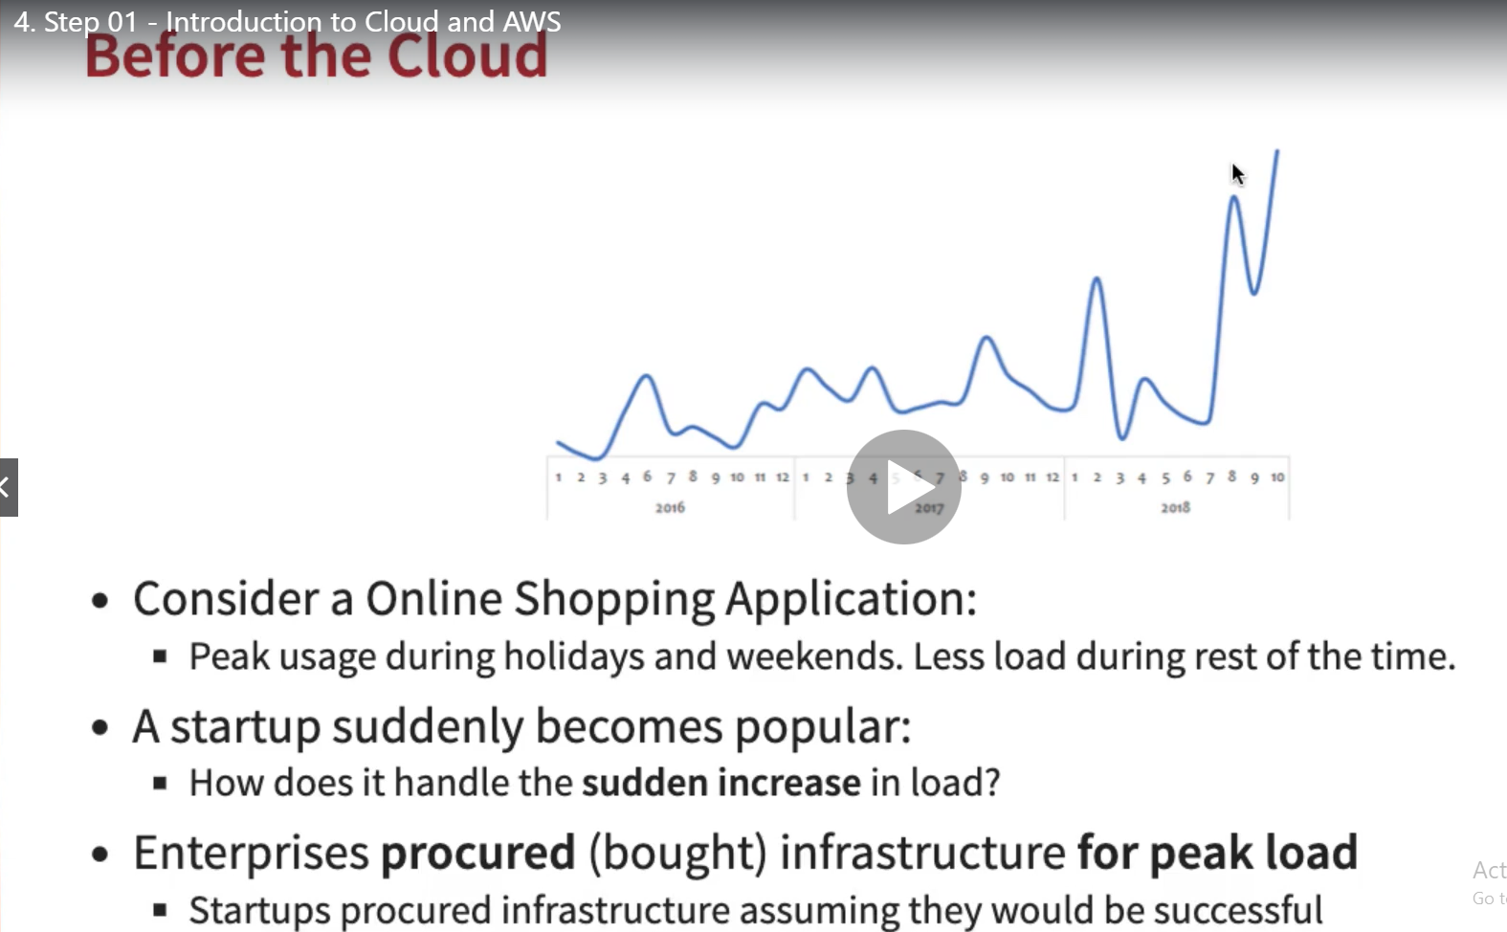

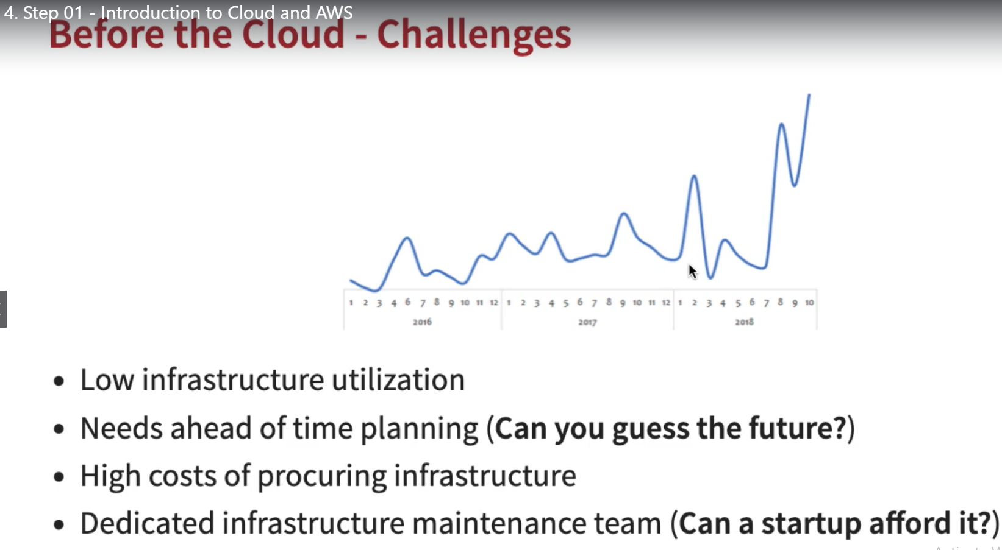

These are main reason cloud started:

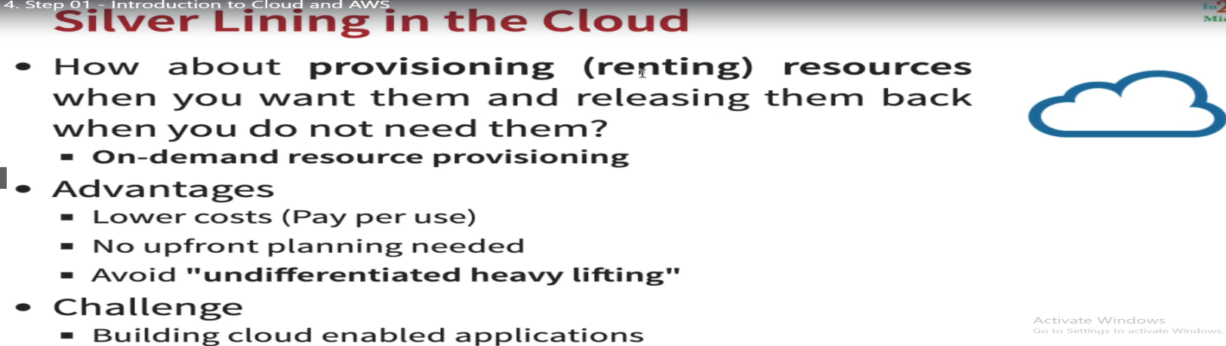

Why AWS

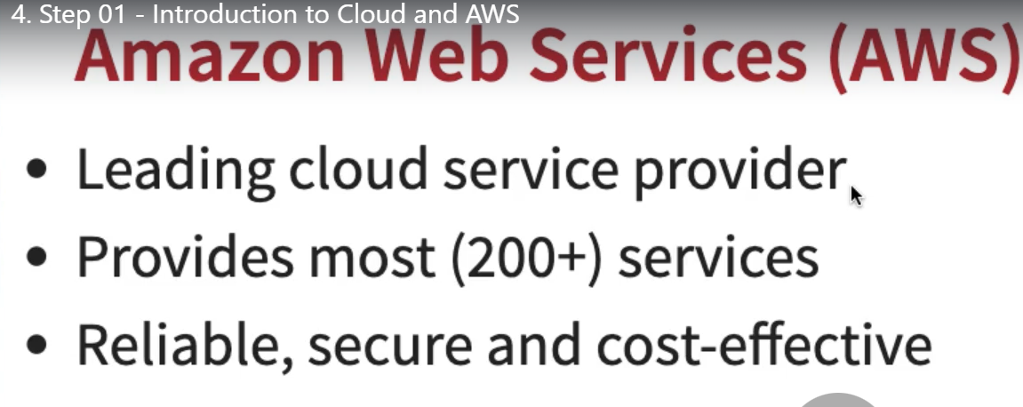

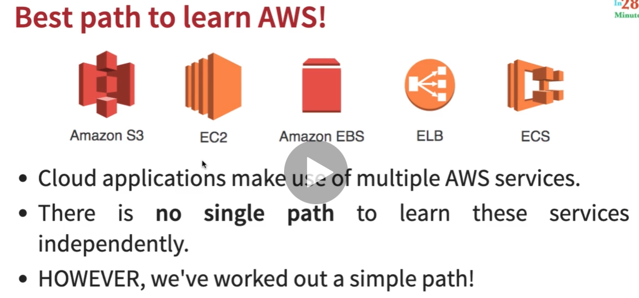

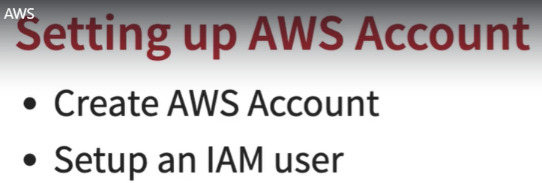

**5- Step2: Creating an AWS root account!** This is just like an admin use that will have complete access for AWS even using this user we can close AWS account. It is strongly recommended not to use root user for day to day activities, even for admin activity it’s better to create different set of users called IAM user. So using root user create IAM user and logged out somewhere secure.

**6- Step3: Creating an IAM (identity and Access management) User for AWS account**! Using IAM service we can create several IAM users and groups and assign them permission. We can assign the permission or policy directly to the user or create a group of users and assign the permission to them.

**7- Step4: Need of Region and Zones:**

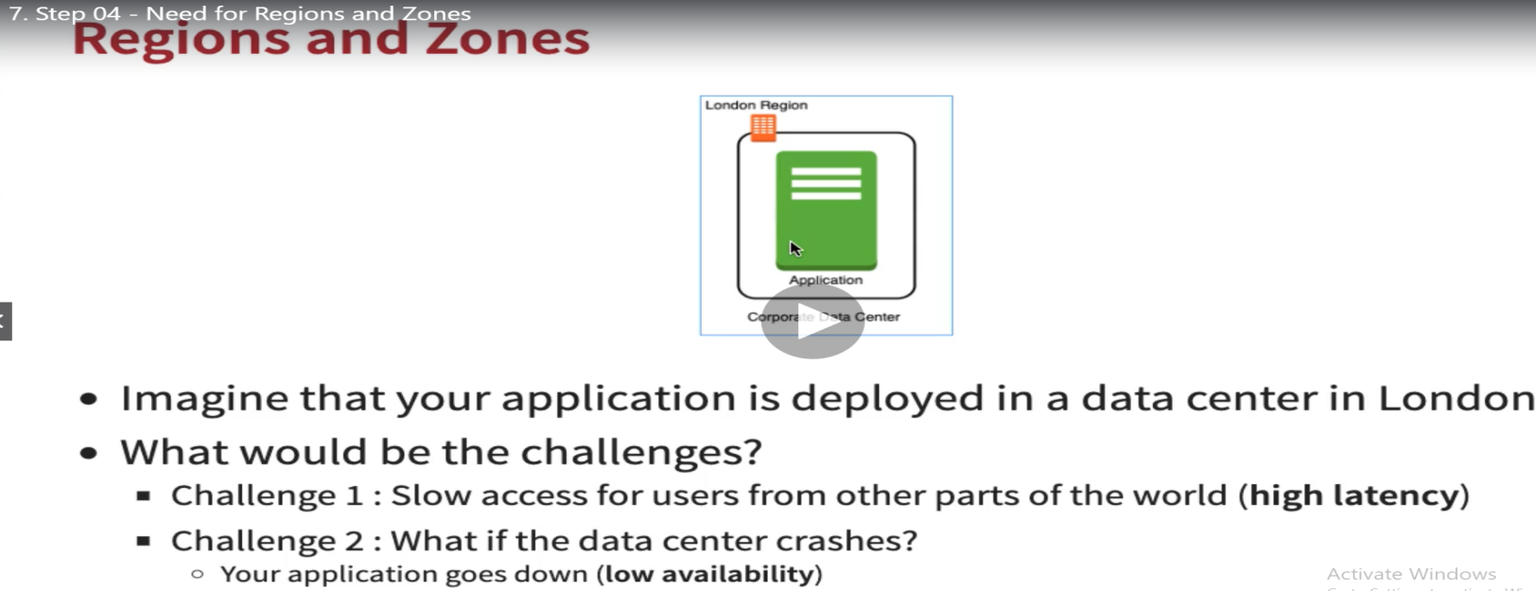

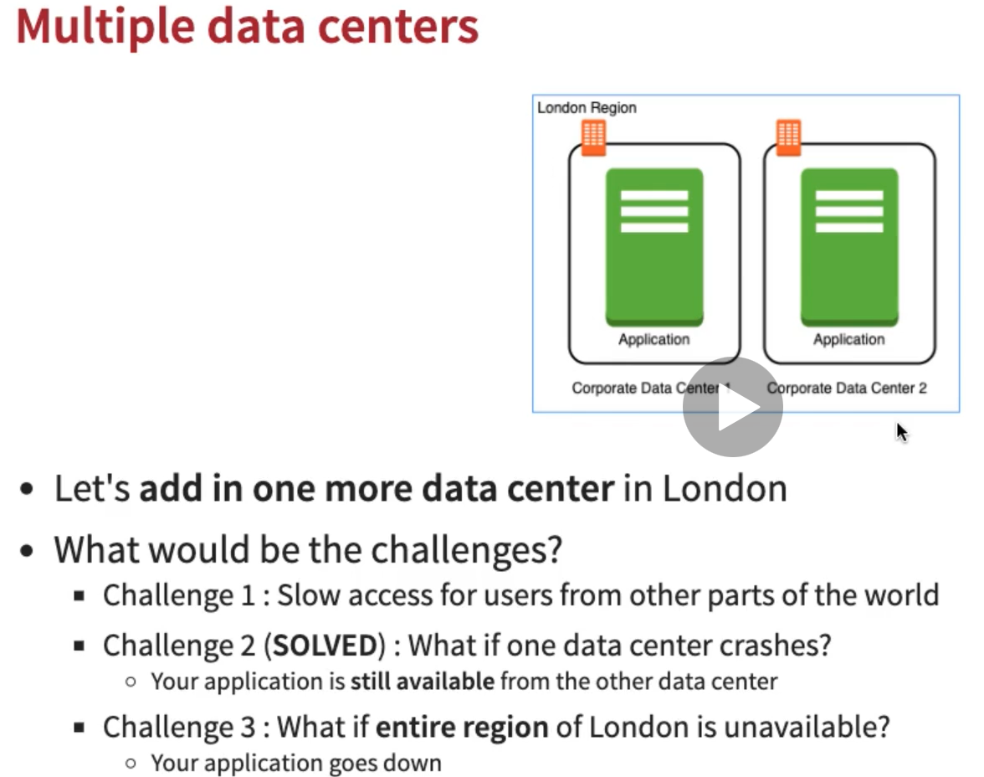

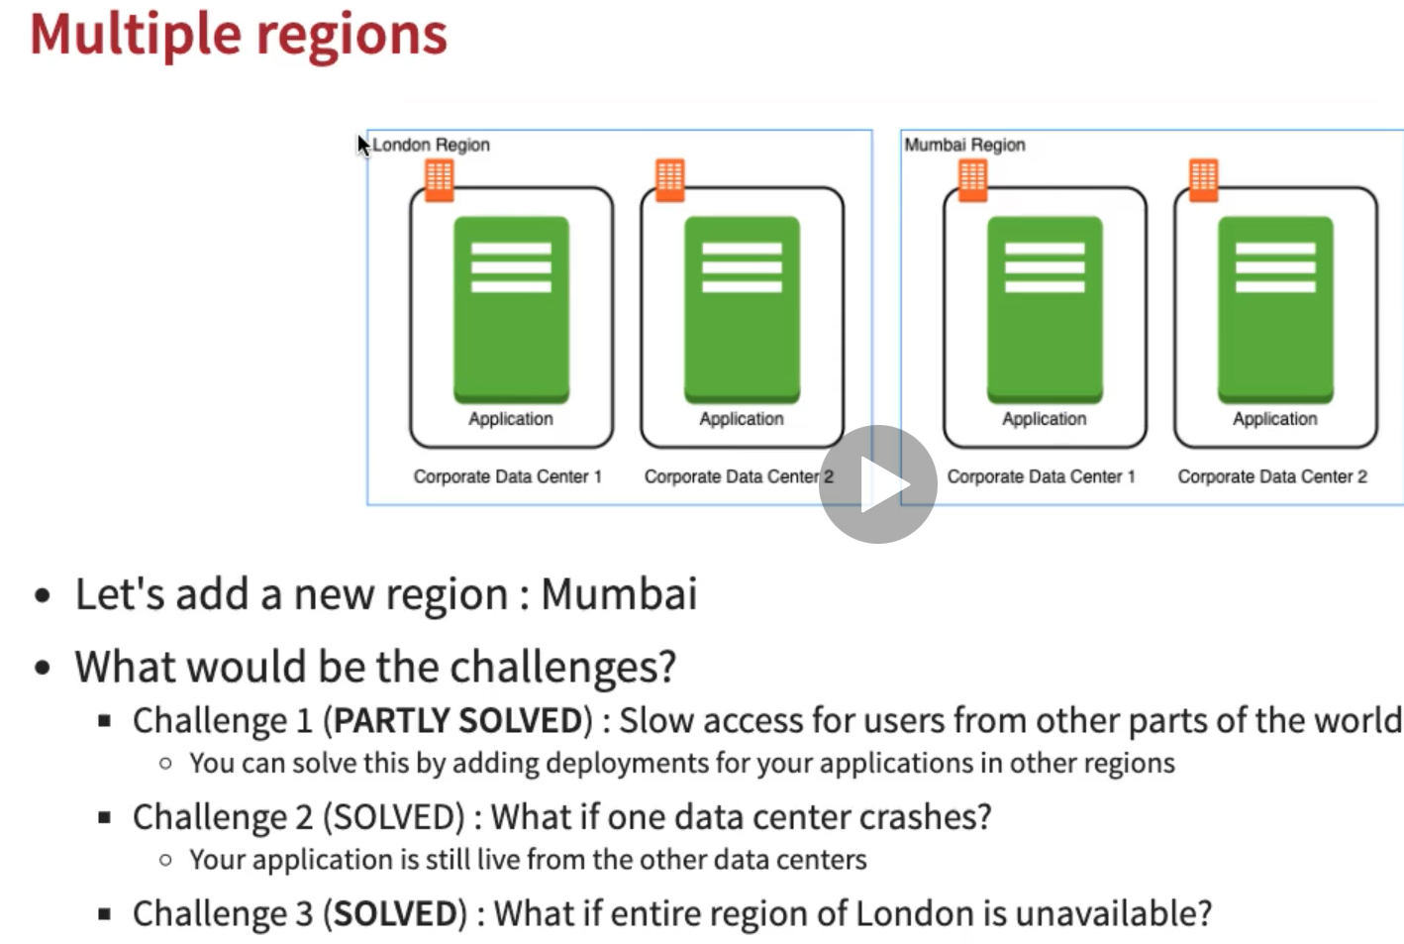

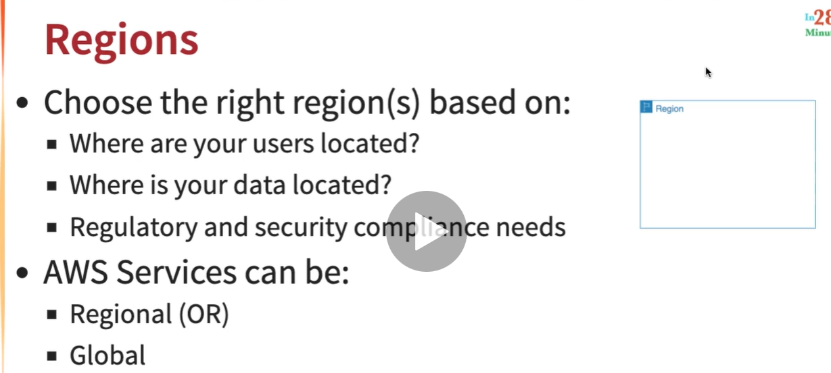

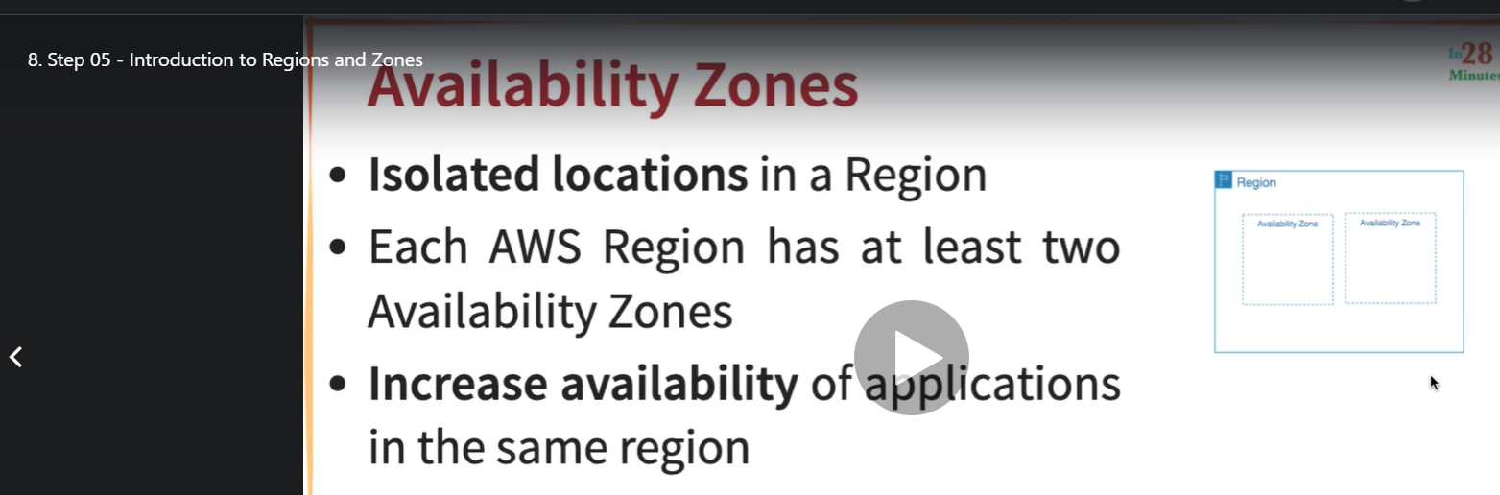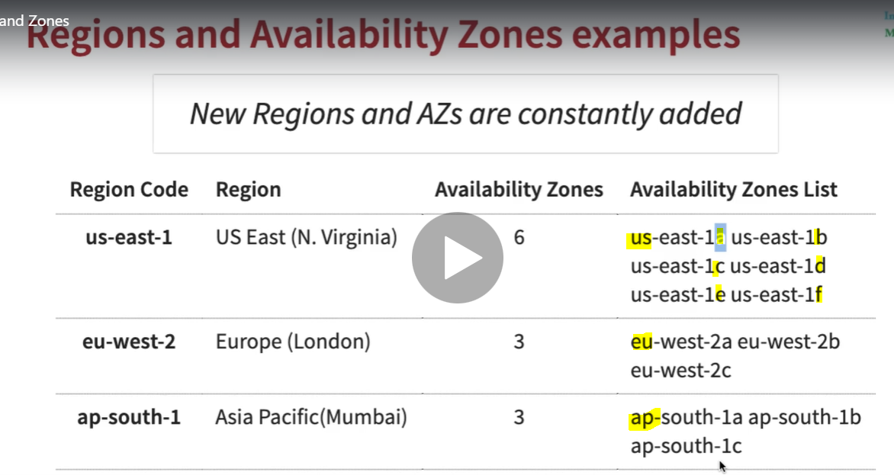

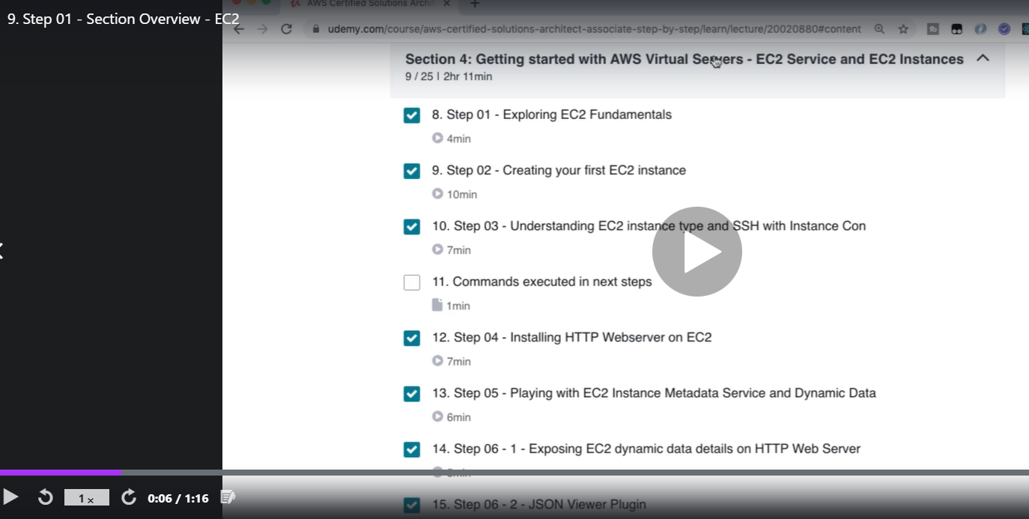

**EC2 Instances: Elastic Compute Cloud (EC2):**

**9. Step 01 - Section Overview - EC2**

**10. Step 01 - Exploring EC2 Fundamentals**

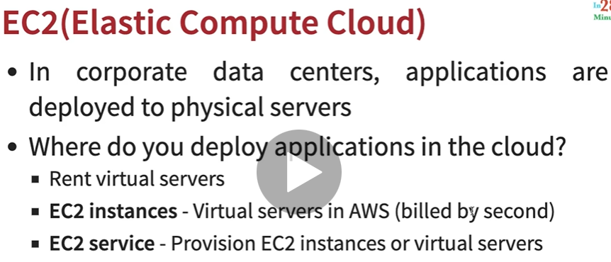

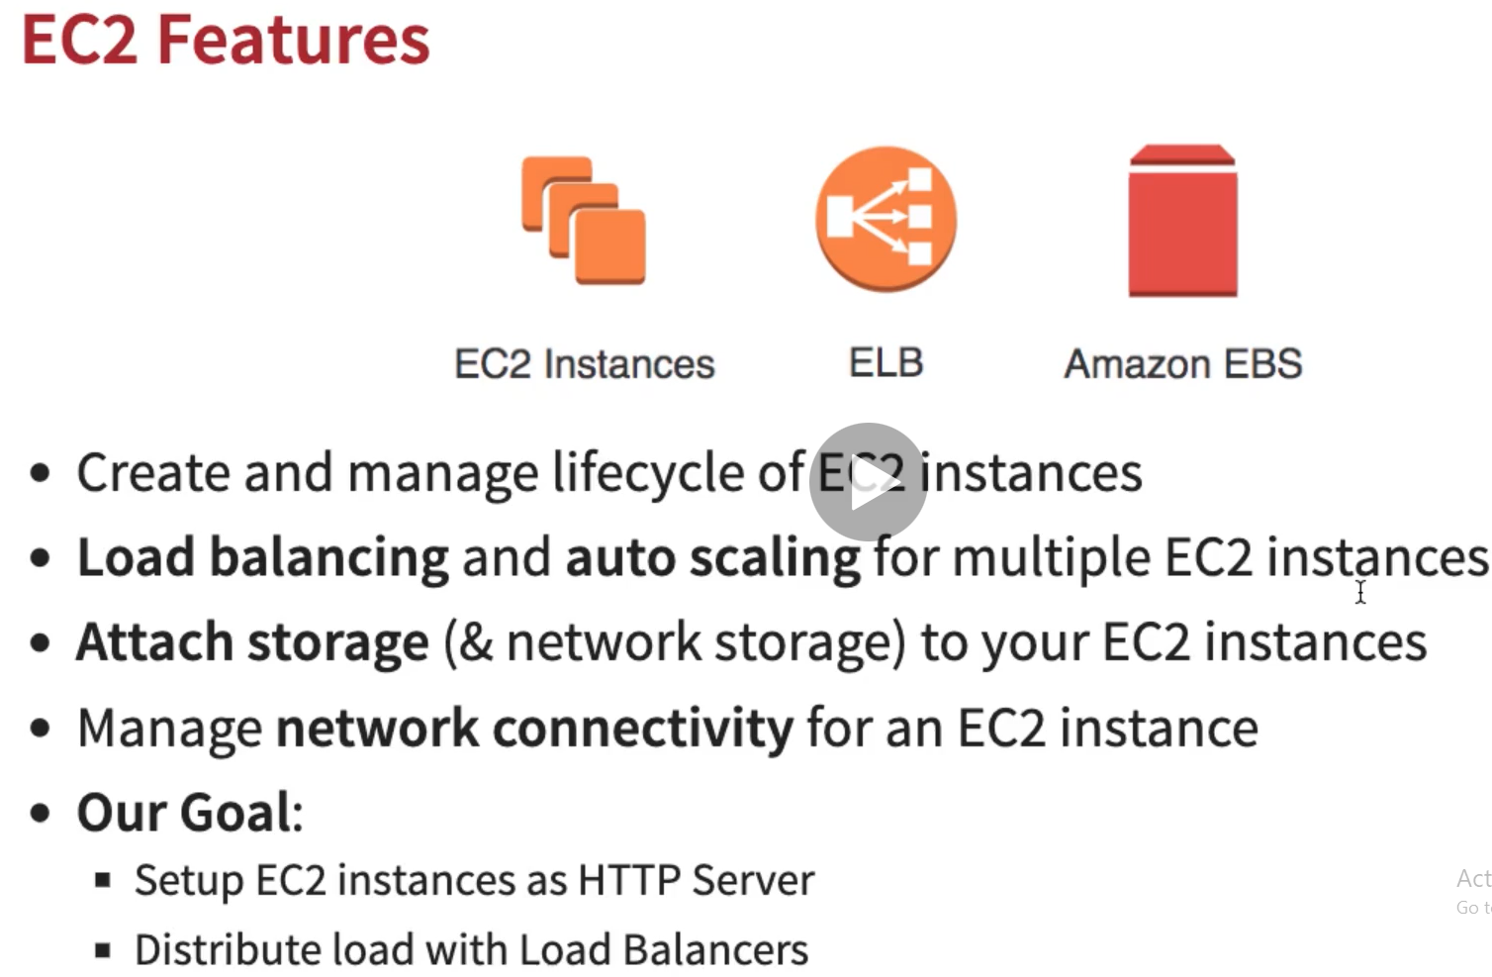

**11. Step 02 - Creating your first EC2 instance**

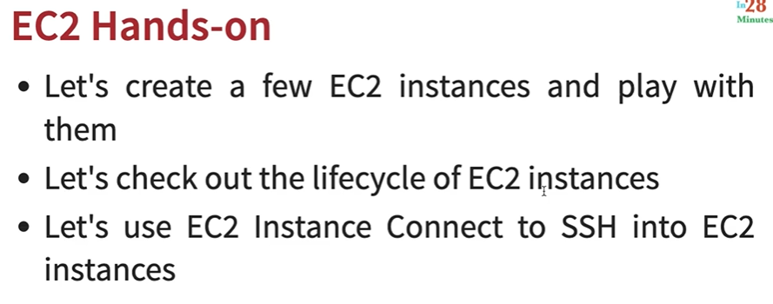

**18. Step 07 - Playing with EC2 Security Groups: Page-31**

**Here we will check the security groups activity by launching google.com before and after configuring security Group;**

1. **Open the AWS command prompt- instance connect**
2. **Do the sudo su**
3. **Fire the command [# curl google.com]**
4. **Now if we have enabled incoming and outgoing security group then we will get html page successfully otherwise we will get timeout error**

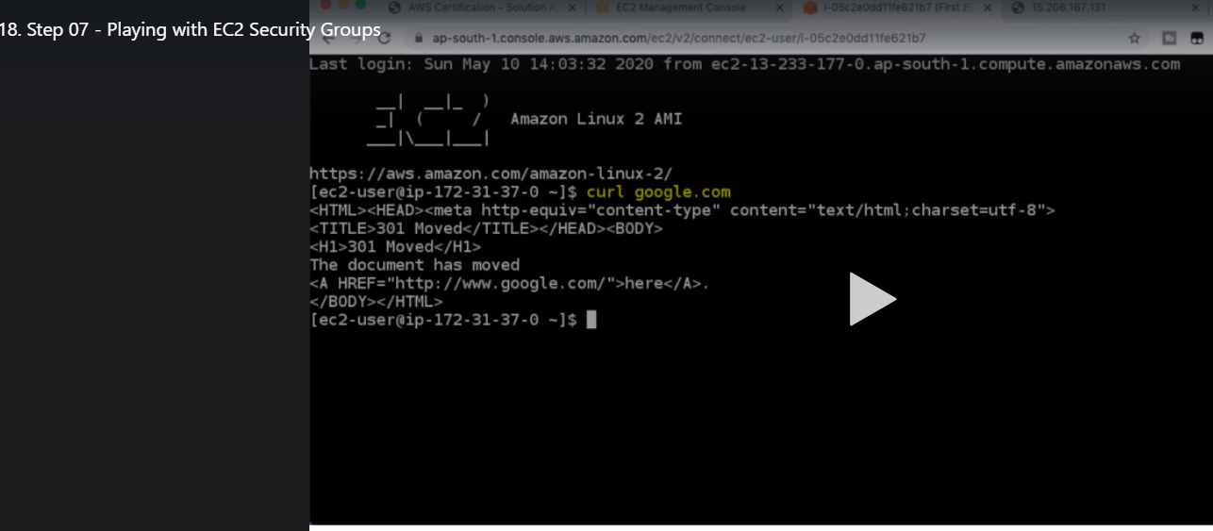

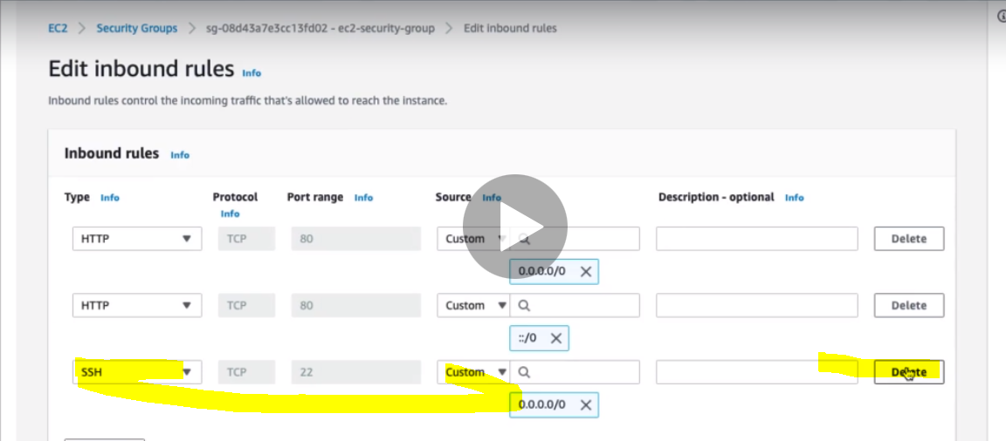

**Now if delete the ssh inbound rule then**

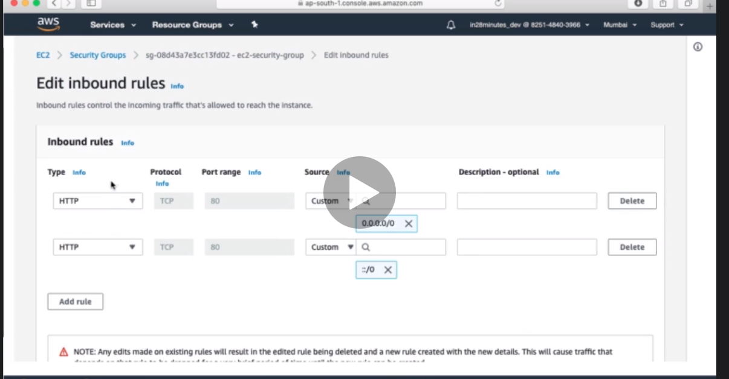

**We would not be able to connect the instance connect command prompt itself.**

**Security group is very important from the certification prospective. Because using SG we can control the inbound and outgoing traffic from the EC2 instance.**

**19. Step 08 - Understanding EC2 Public and Private IP Address’s : pdf page 33**

**EC2 IP Addresses**

* Public IP addresses are internet addressable and it can be used from the internet to access EC2 instances. Using public IP addresses we would be able to access the web server installed on EC2 instances.
* On the other hand the Private IP addresses are internal to a corporate network and these private addresses cannot be used outside the network
* You CANNOT have two resources with same public IP address, because public IPs are on the internet.
* HOWEVER inside the corporate network, two different corporate networks CAN have resources with same private IP address
* All EC2 instances are assigned to a private IP addresses, so if we have 100 EC2 instances so each of them would have their own private addresses, the public IP address are not mandatory we can action create public IP addresses during the EC2 instance creation
* (**Remember**) When you stop an EC2 instance, public IP address is lost and when we start EC2 again then we would get different public IP address from the previous IP Add. However the private address will remains same.
* DEMO: EC2 public and private addresses

If we go to instances then we will get both the IP addresses:

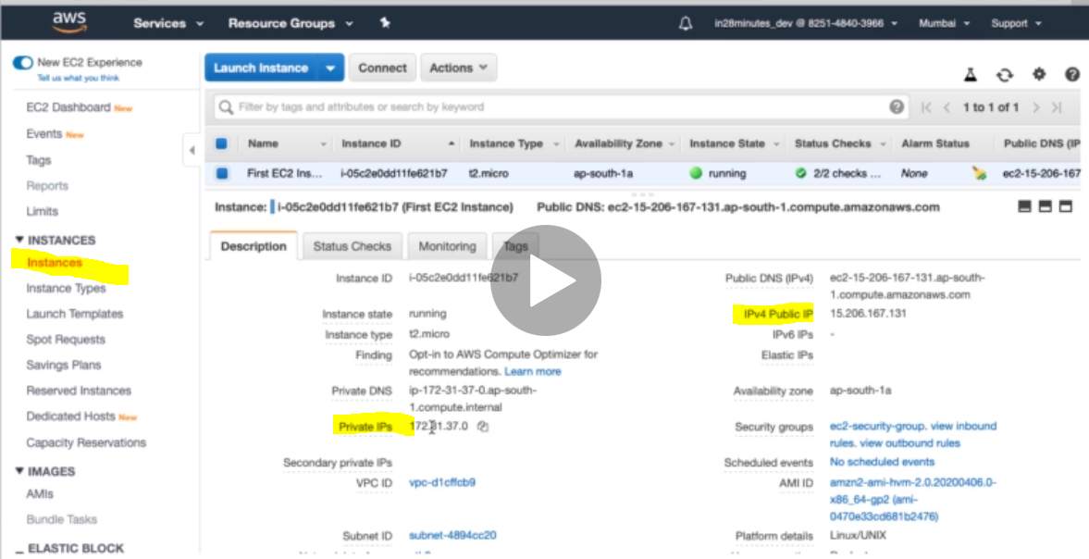

For example in the earlier section we have used the Public IP address to access the web page.

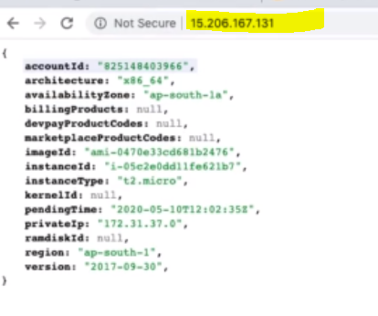

Here we are trying access EC2 instance web page from outside using public IP address.

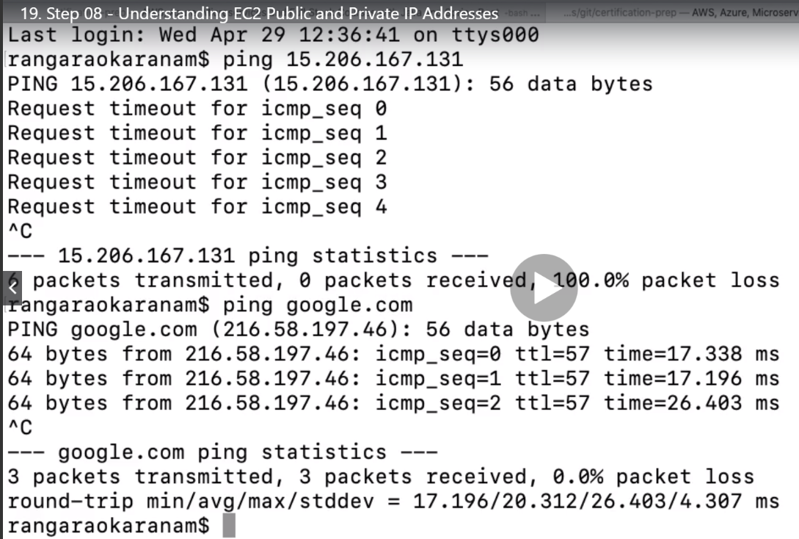

**As here we can see that we are trying to ping public IP and it is giving timeout while google.com ping successfully. Why?**

**Ans: Here google.com is running on http at port 80 which is already enabled in the security group while Ping uses different port which is not yet enabled in the security group.**

**To enable ping:**

1. **Let’s go to EC2 instance Security Group**
2. **Edit inbound rule**

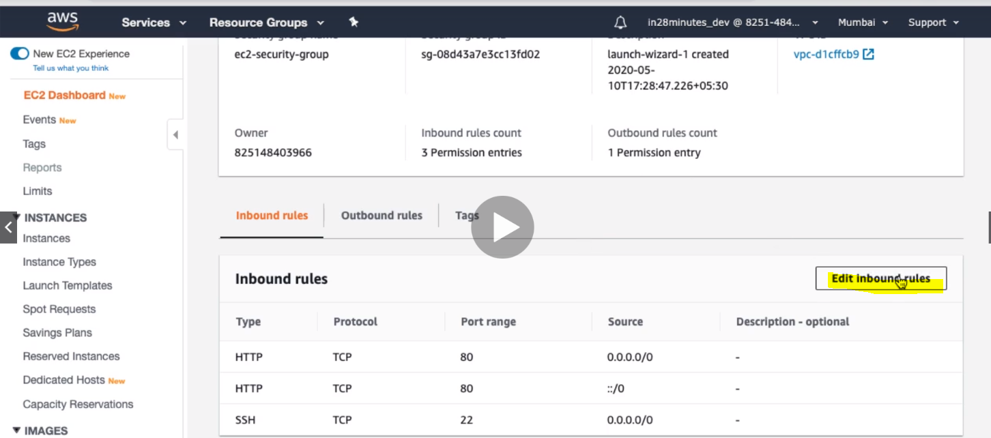

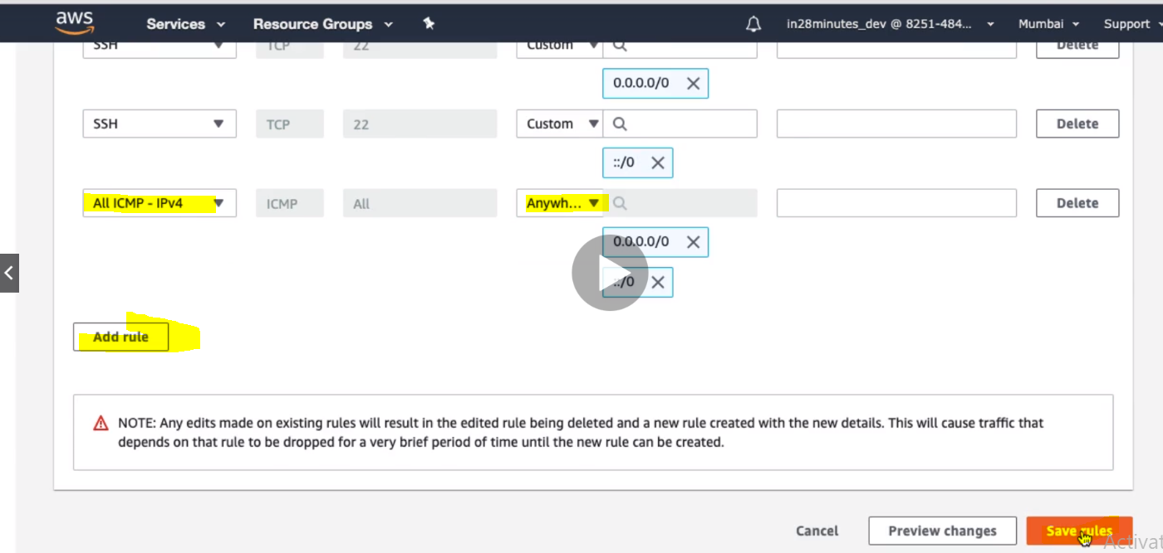

1. **Click on Add rule to add new rule**
2. **Select type - All ICMP-IPV4**
3. **Select source – Anywhere and save rules**

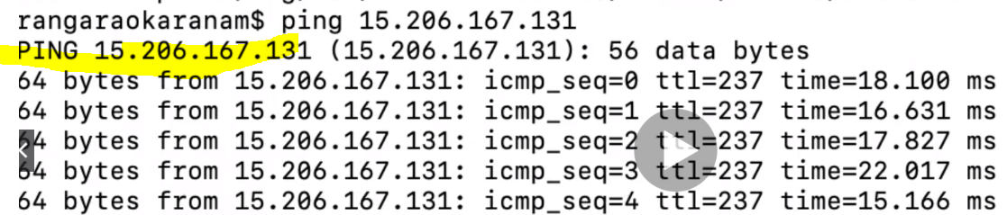

**Now when we execute ping command again then we start getting ping response.**

**Now let’s ping the private IP address: Take the private IP address from EC2 instance or from web response:**

|  |  |
| --- | --- |
|  | **So we can see that it is getting timeout. Because we have tried to ping it from outside of EC2 instance.**  **Now let’s ping the same private IP from inside network i.e. from instance connect** |

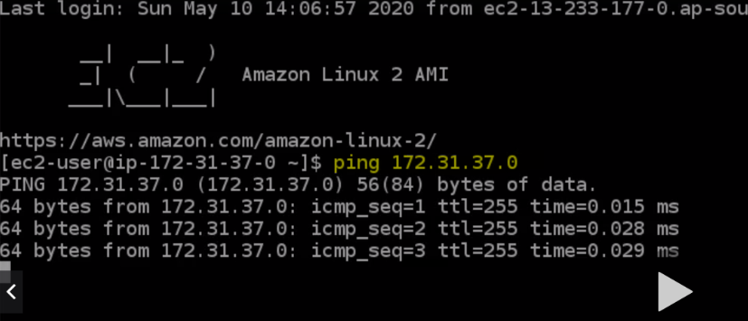

**Now we are getting the response correctly**

**Case: Now let’s stop and start the EC2 instance once again and check it out:**

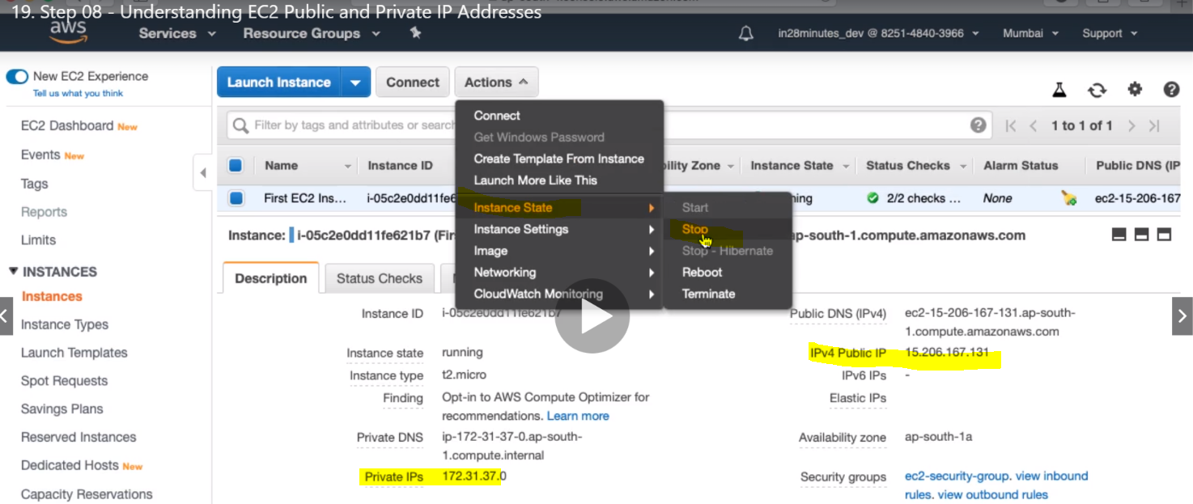

**Right now before stop public IP- 15.206.167.131 and private IP- 172.31.37.0 .**

**Now let’s stop EC2.**

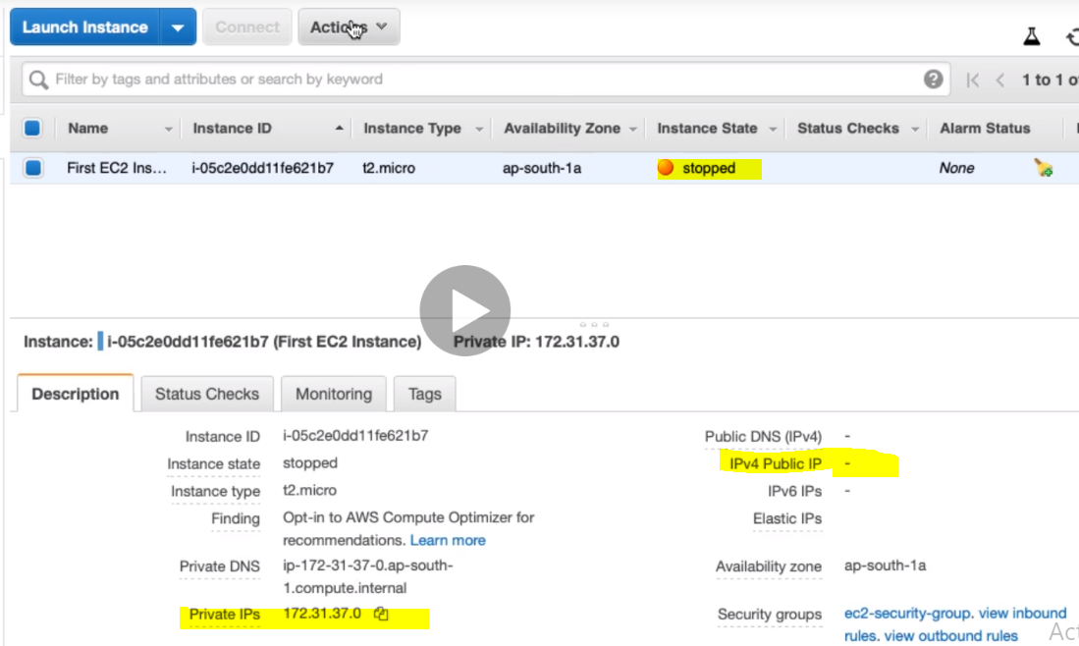

**So we can see that when EC2 stopped then its public IP gets disappeared while private IP still exist.**

**Now let’s start the EC2 instance again and check:**

**As in the below screen we can see that once EC2 gets start once again then again its public IP gets assigned but this is the different IP address before stopping but there is no any effect on public IP address, before and after start of EC2 instance.**

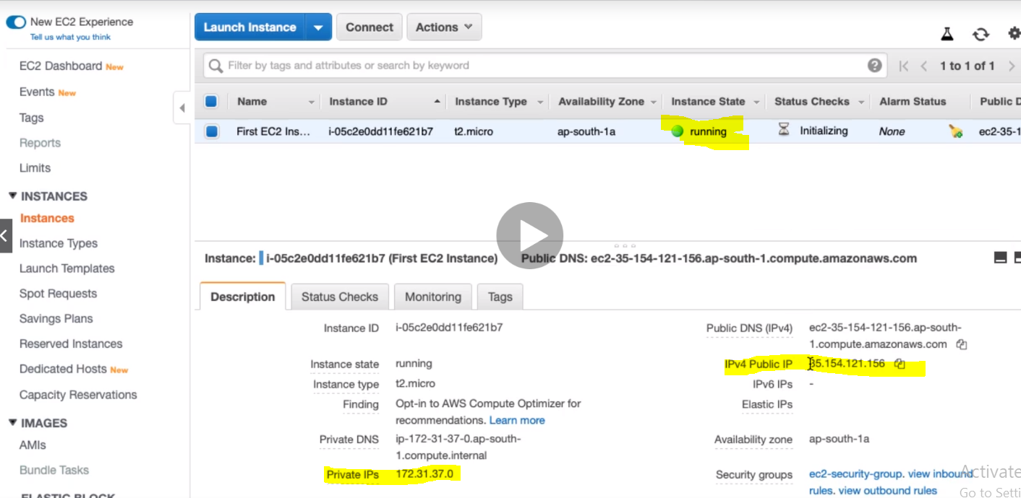 **Now if we run the above web page using this new public IP then we will get response but if try to run with the old IP then won’t get any response.**

**But this keep changing IP address is not good because let’s say if we have shared this public IP address to one of my client to access EC2 instance web server web page and by mistake if someone EC2 instance stop and restart then in this case my client would not be able to access the same page with the already shared public IP because now the public IP has got changed. How to fix that? Using Elastic IP Address:**

**Note: One thing that we need to note that instead of stop and start if we choose to reboot the EC2 instance then in that case public IP address does not change at all.**

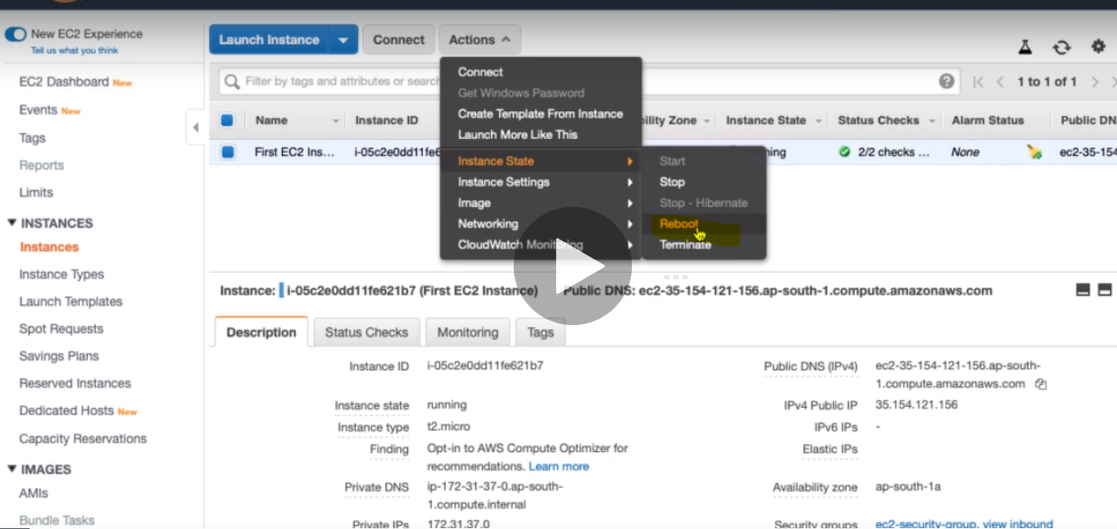

**20. Step 09 - Understanding Elastic IP Addresses**

How do you get a **constant public IP address** for an EC2 instance? Quick and dirty way is to **use an Elastic IP**!

**Note:**

**So this Elastic IP Address is quick solution where only one EC2 instance is involved but when we have multiple EC2 instance is involved then we have achieve this using load balancer.**

**DEMO**: Using Elastic IP Address with an EC2 instance:Let’s see how to create Elastic IP and attach it to EC2

1. Go to Network and Security > and inside this we will get Elastic IPs link

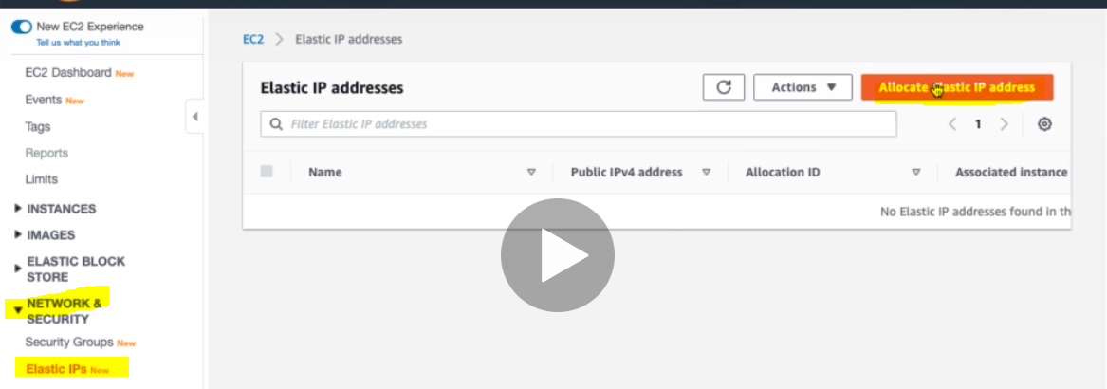

1. Click on Allocate Static IP address.

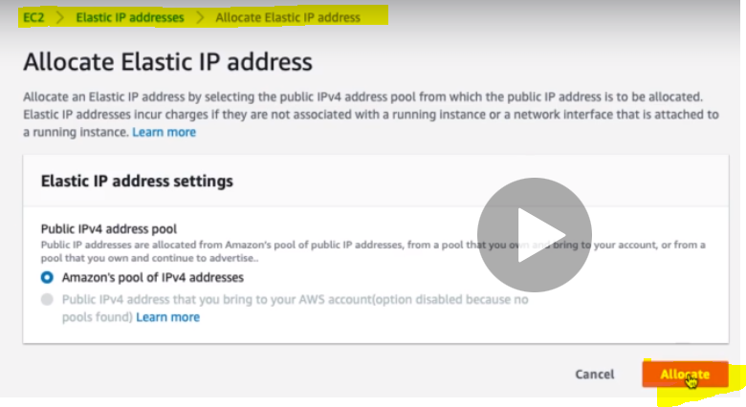

Click Allocate: So Elastic IP will be created for us and allocated.

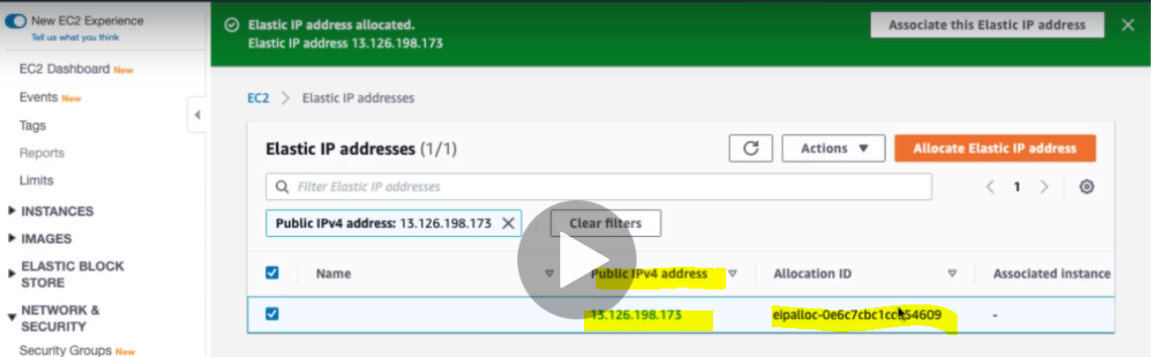

Now let’s assign this IP to our EC2 instance:

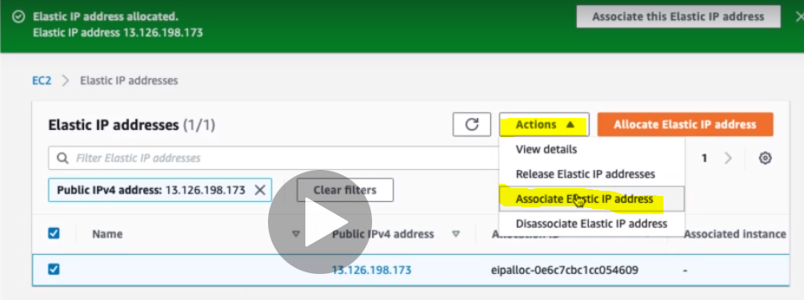

Actions > Associate Elastic IP address:

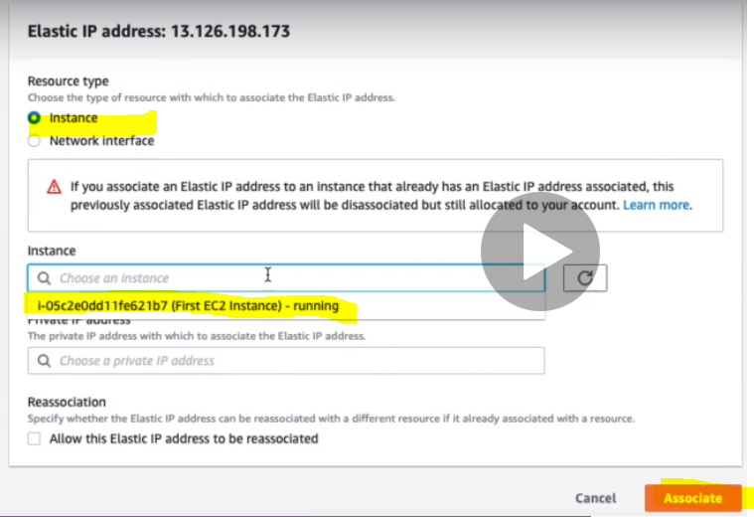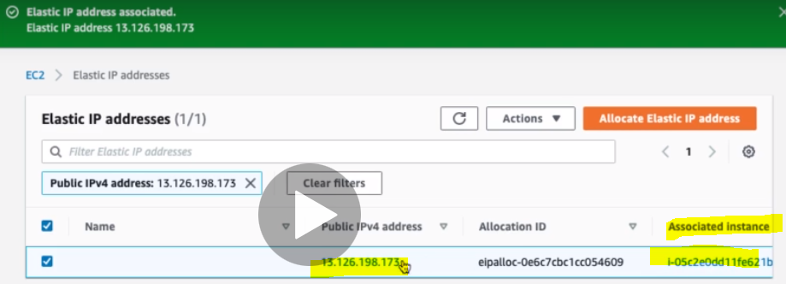

We can see that now the Elastic IP address is associated with the EC2 instance.

|  |  |
| --- | --- |
|  | Now we can use Elastic IP address to execute the request and now this IP will not going to change after stop and start. |

Now if we go to EC2 instance:

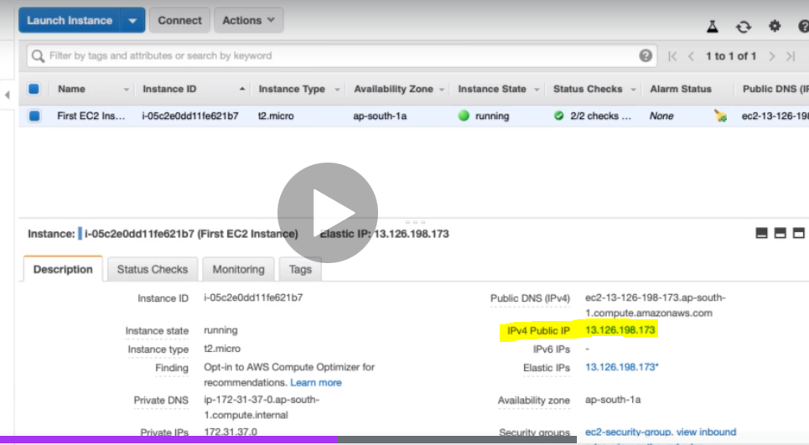

Now if we hover the mouse on public IP then we will get one link which will take us to Elastic IP allocation page.

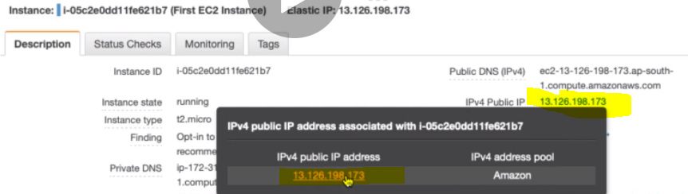

Click on the link

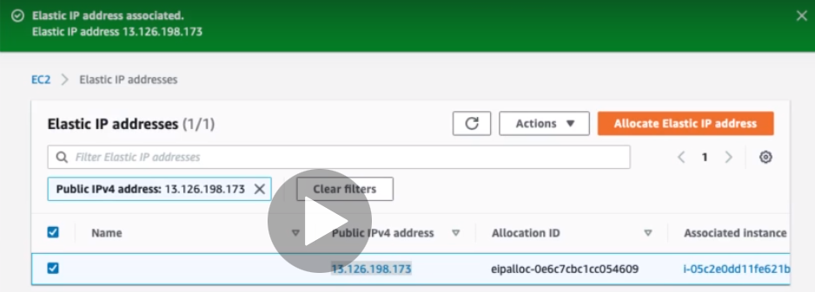

Got the Elastic IP address page:

Now if we stop the instance the public IP is not going to change:

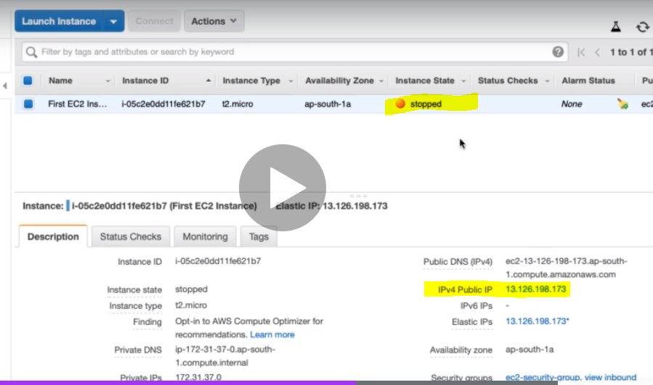

**Elastic IP Addresses - Remember**

* Elastic IP can be switched to another EC2 instance within the same region
* Elastic IP remains attached even if you stop the instance. You have to manually detach it as given below.

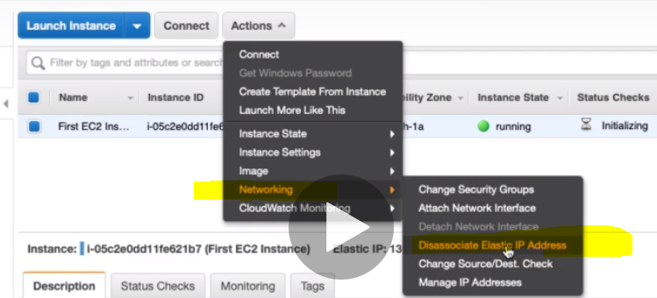

* Remember: You are charged for an Elastic IP when you are NOT using it! Make
* sure that you explicitly release an Elastic IP when you are not using it
* You will be charged for Elastic IP when:
  + Elastic IP is NOT associated with an EC2 instance OR
  + EC2 instance associated with Elastic IP is stopped

So if we are not using E IP then its better, release it. Elastic IP Address > Actions > Release Elastic IP Address

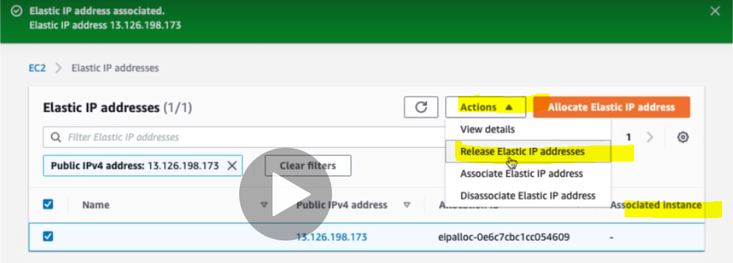

**Release Elastic IP Address when you stop EC2 Instances**

**An Elastic IP address doesn’t incur charges as long as all the following conditions are true:**

* The Elastic IP address is associated with an EC2 instance.
* The instance associated with the Elastic IP address is running.
* The instance has only one Elastic IP address attached to it.
* The Elastic IP address is associated with an attached network interface, such as a Network Load Balancer or NAT gateway.

**If you stop/terminate an EC2 instance, do not forget to release the Elastic IP address attached to it.**

<https://aws.amazon.com/premiumsupport/knowledge-center/elastic-ip-charges/>

**23. Step 10 - Simplify EC2 HTTP server setup.**

How do we reduce the number of steps in creating an EC2 instance and setting up a HTTP Server?

In the previous step we have created EC2 instance and install the Apache web server to launch Http web server. However there are several other simple steps for creating EC2 instance and setting up the Http server setup and configured the web page (index.html) to be returned.

Let's explore a few options:

1. **Using Userdata**
2. **Using Launch Template**
3. **Using AMI (i.e. creating Custom Amazon Machine Image)**

**(1)Using Userdata::** The Userdata is nothing but the simple script that can be configured to be executed at launch to EC2 instance.

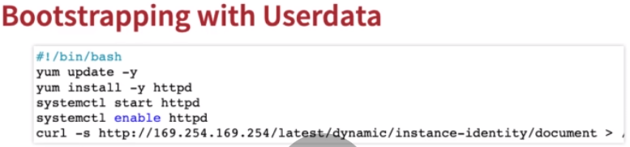

|  |
| --- |
| #!/bin/bash  yum update -y  yum install -y httpd  systemctl start httpd  systemctl enable httpd  curl -s **http://169.254.169.254/latest/dynamic/instance-identity/document > /var/www/html/index.html** |

Here the above script we have executed manually one by one

|  |  |
| --- | --- |
| yum update –y | To update all the installed packages in the EC2 |
| yum install –y httpd | To install apache http server |
| systemctl start httpd | To start http server |
| systemctl enable httpd | To enable http server with EC2 |
| curl –s http://169.254.169.254/latest/dynamic/instance- identity/document > / var/www/html/index.html | Create web page inside html folder using curl |

**Now here instead of executing the command manually we will use execute these command during the launch of EC2 instance, which will execute these command automatically**

* **Bootstrapping**: This is the processes which will Install OS patches or software when an EC2 instance is launched just to make sure that all the security related stuffs are up to date.
* In EC2, we can configure above **Userdata** to bootstrap
* Lookup user data -***http://169.254.169.254/latest/user-data/***
* **Using the above url we can see the all the user data configured to EC2**

**Steps: Creating a new EC2 instance**

1. **Login to AWS management console and go to EC2 Service**
2. **Click on Launch Instance to create new EC2 instance**

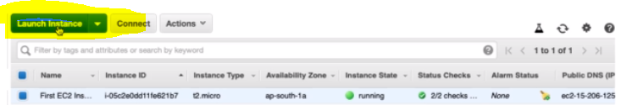

1. **Select Amazon Linux 2 AMI**

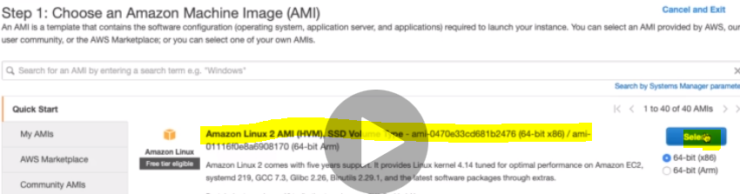

1. **Choose t2- Micro as the instance type:**

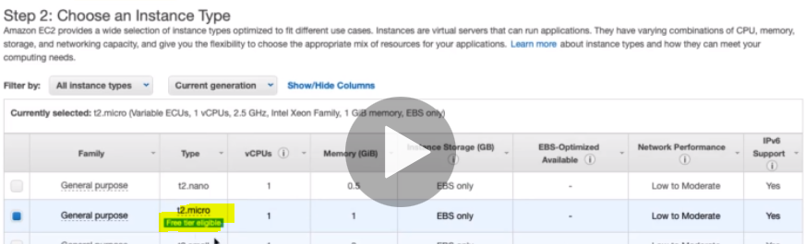

1. **Now in the next screen we will configure the Userdata**

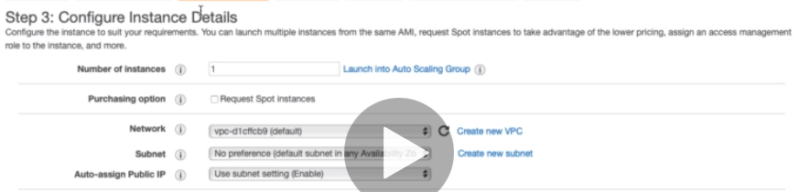

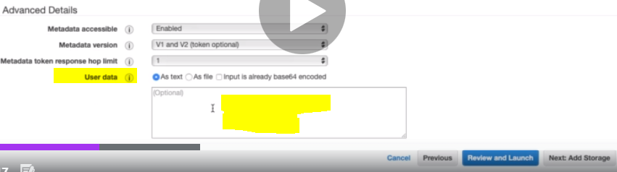

**Now here in the user data text area box we will put user data as text: as given below:**

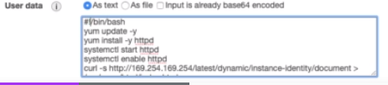

1. **Click on Add storage:**

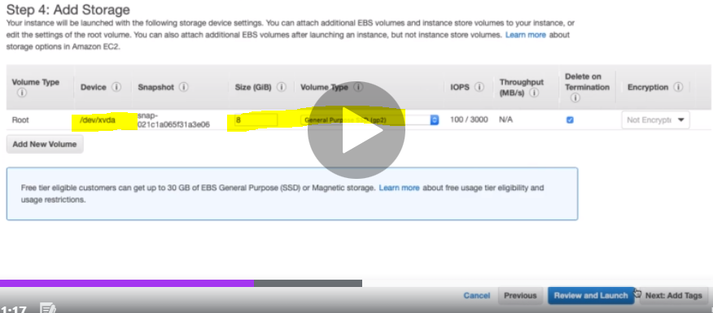

1. **Click next to Add Tags to this EC2**

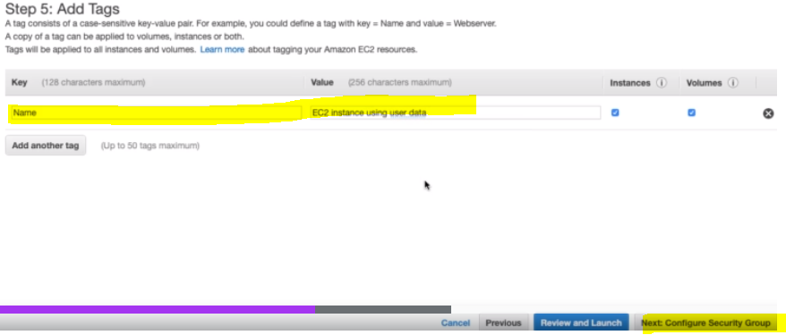

1. **Now let’s configure the security group:**

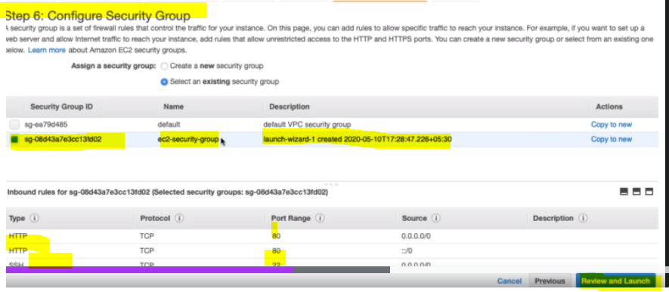

So here we will use existing security group and finally Review and Launch

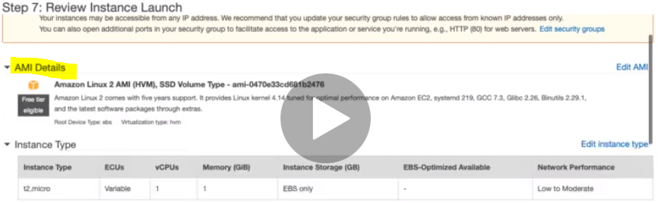 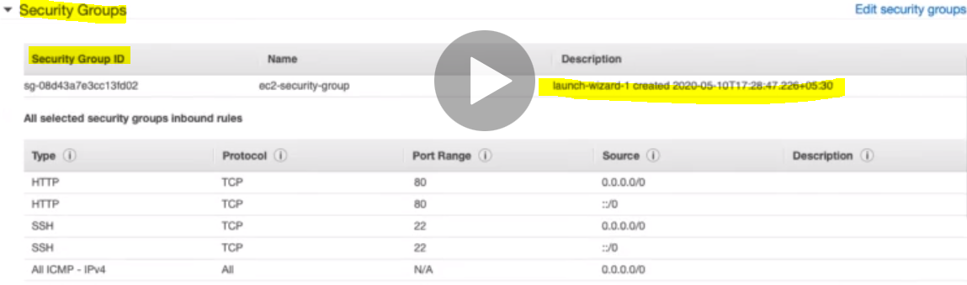 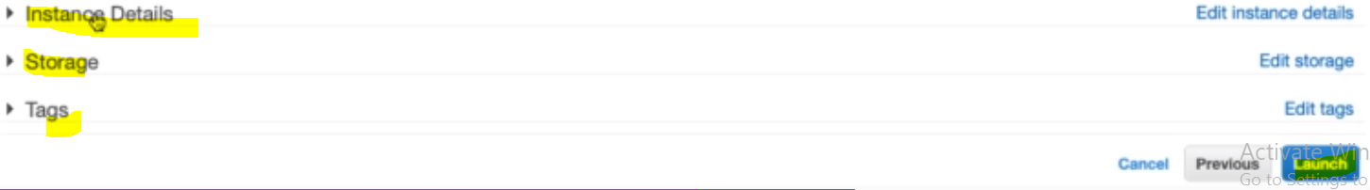

Instance detail : Can check the user data; Storage: will show the storage ; Tags: will show the tags info

Finally after reviewing click on Button **Launch**:

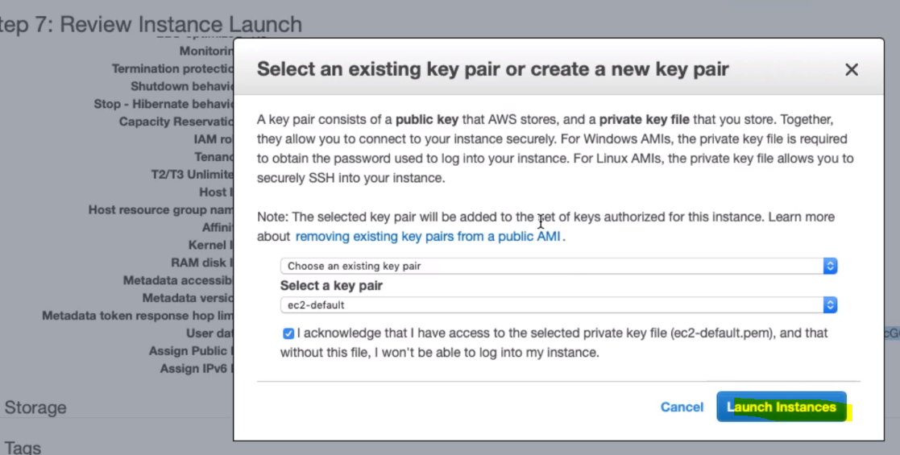 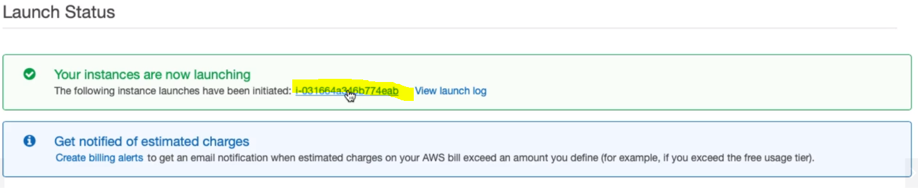

It will take a while for launching the new instance and then we will see below running instance with public IP and other details 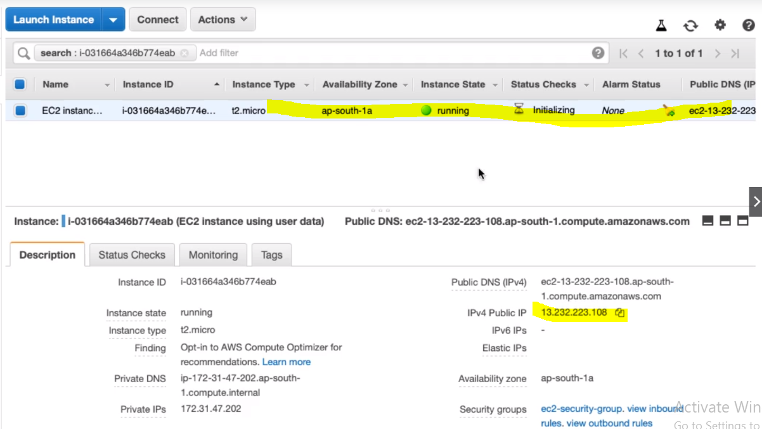

Let’s execute the web page configured in the user data using its public IP

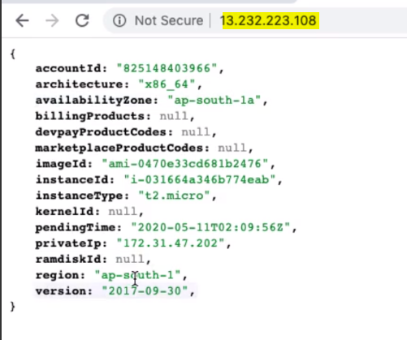

So finally we have launched new EC2 instance with http server and web page using user data

If we remove the filter from the search box then we will get two running instance

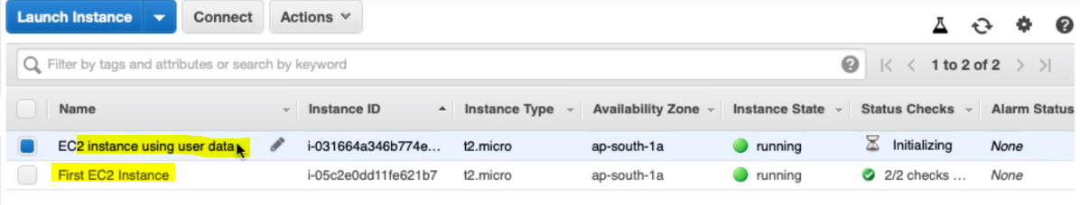

If we have any issue in running then we can check the user data as by given screen below:

Checking the user data:

1. Using GUI

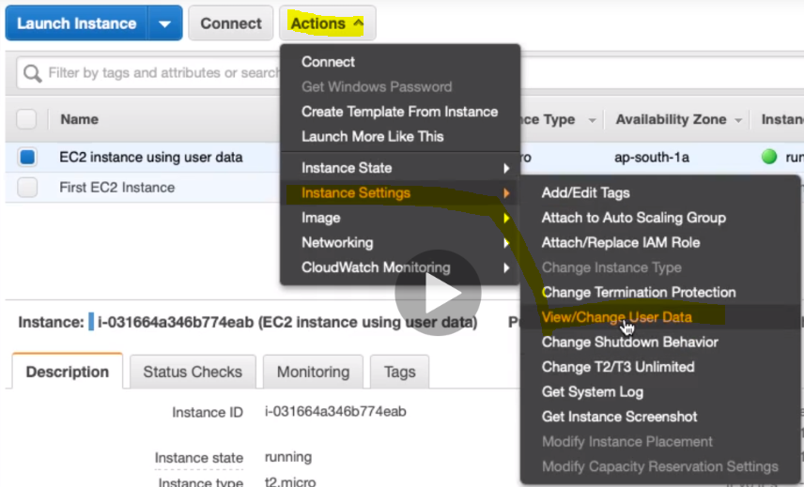 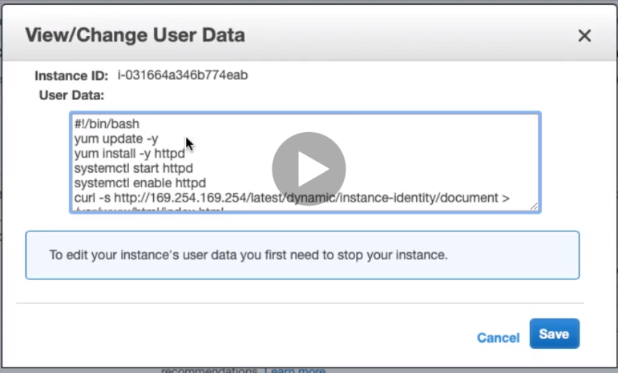

(2) Checking the user data using EC2 command prompt – connect instance: using URL

* Lookup user data -***http://169.254.169.254/latest/user-data/***

First let’s check with first running EC2 Instance and try to know what happens 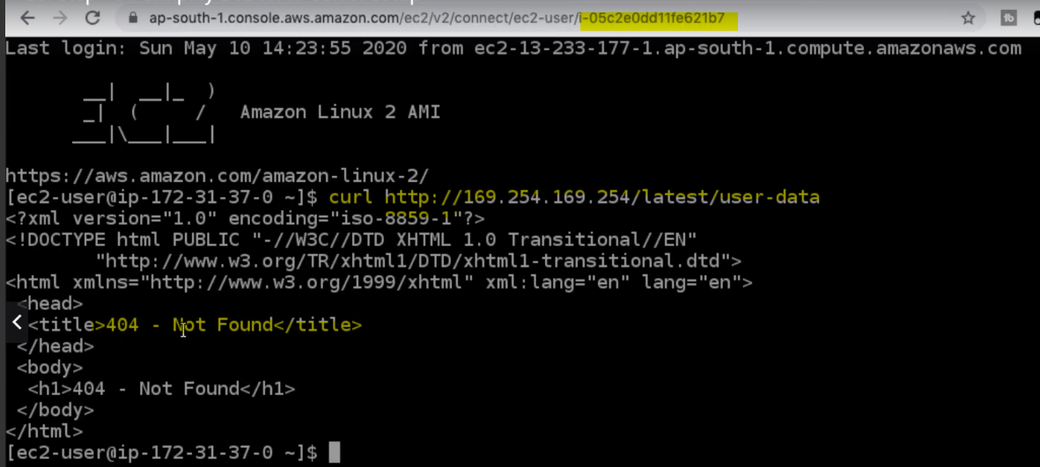

So we can see that with the old instance id it giving 404. So now let’s connect latest created EC2 instance CMD. We can connect EC2 CMD by two ways.

1. Select the EC2 instance and click the connect

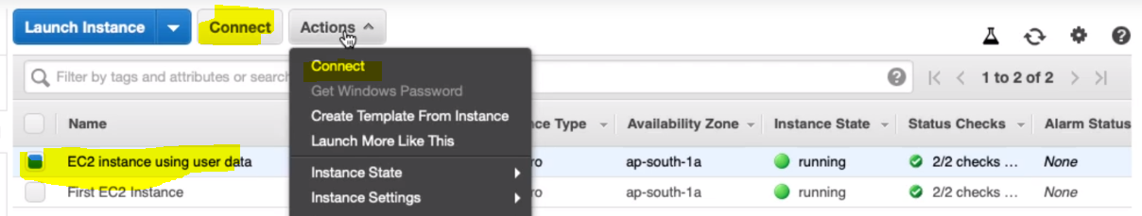 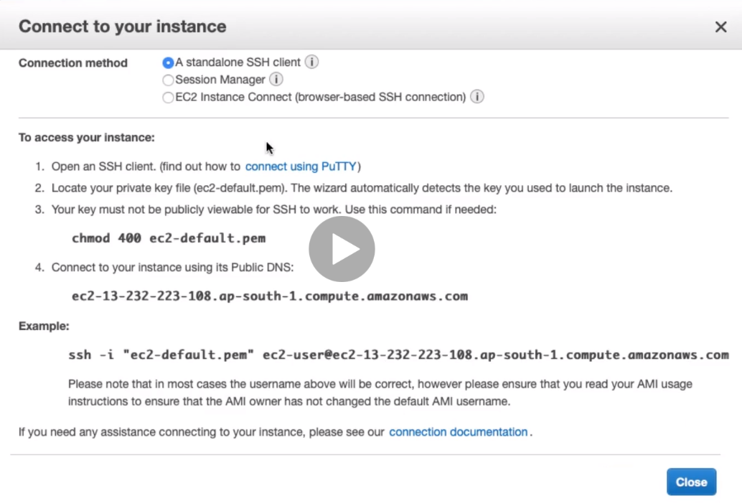

Check the third check box [EC2 Instance connect (browser-based SSH connection)]

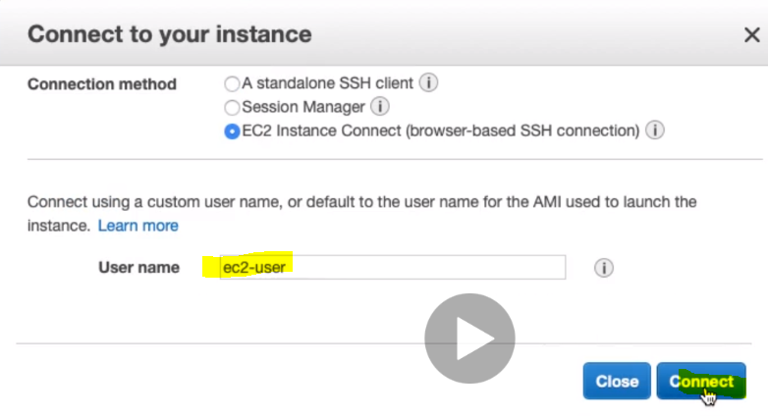

1. Another option is a kind of short cut option. Select the EC2 instance and copy its instance ID and paste in the already running instance URL

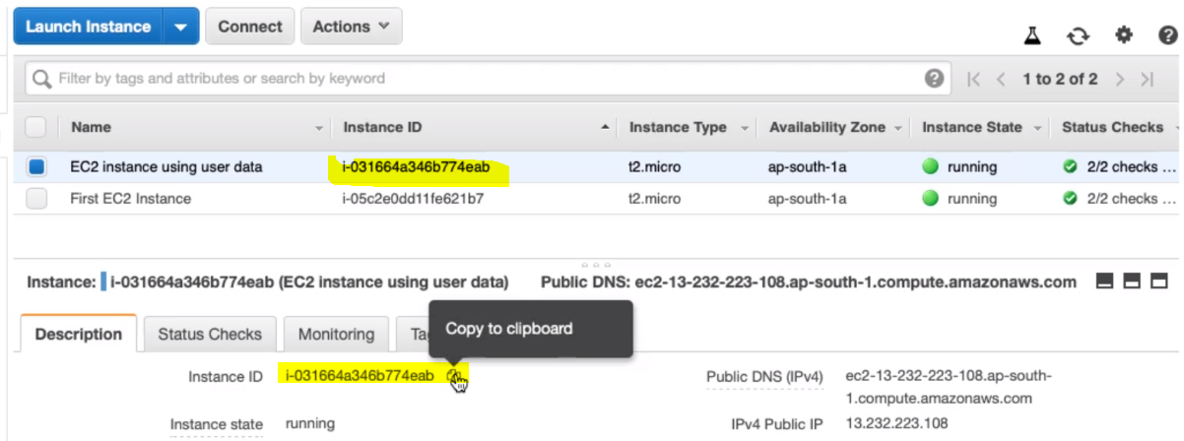

And now change the earlier running URL:

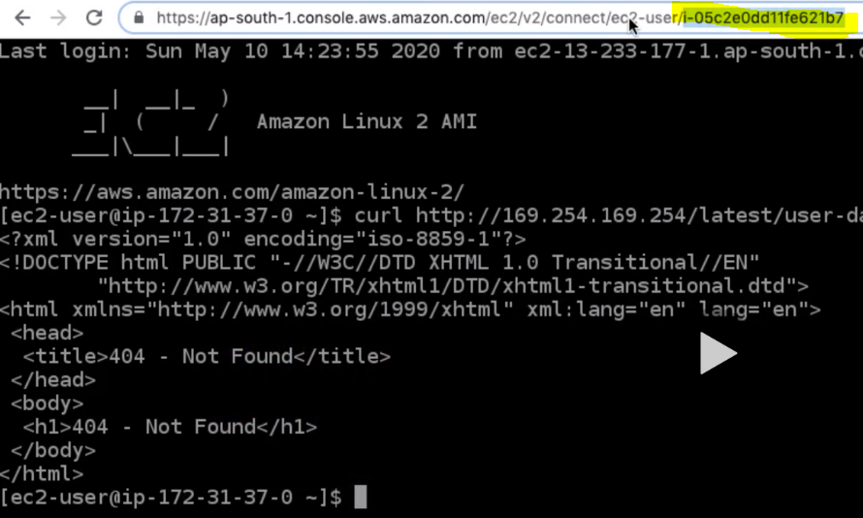

Latest URL will now:

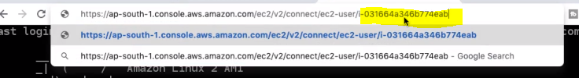 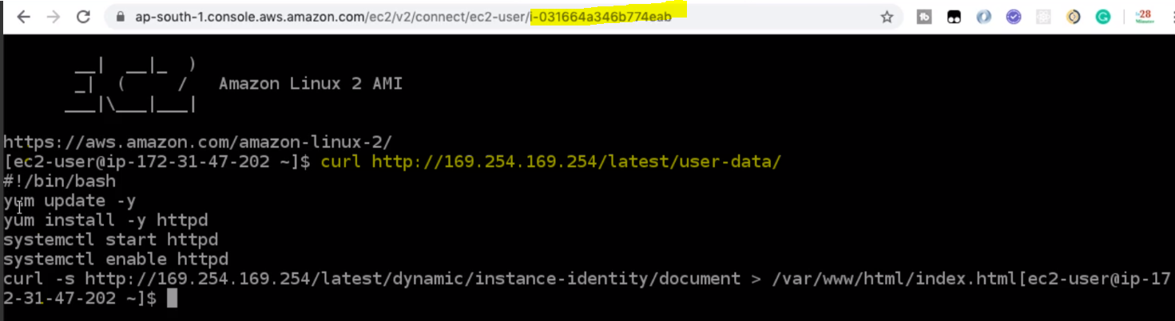

And now we are able to see the User data using URL:

So in this step we have used user data to configure http server and web page at the EC2 launch, we have seen the configured user data using GUI and CMD using url.

Now next we will see Launch EC2 instance using Template:

**25. Step 11 - Creating Launch Templates for EC2 instances**

AS so far in the privious steps we have seen that during EC2 instance laucning we have to provide (AMI ID, instance type, and network settings like security group) every time. So why do we need to this long step?

Do we have any template that we can use for creating EC2 instance every time?

Ans: Yes we can use Launch Template:

It Allow you to launch Spot instances and Spot fleets as well

Steps:

1. Go to Instances > Click Launch Templates

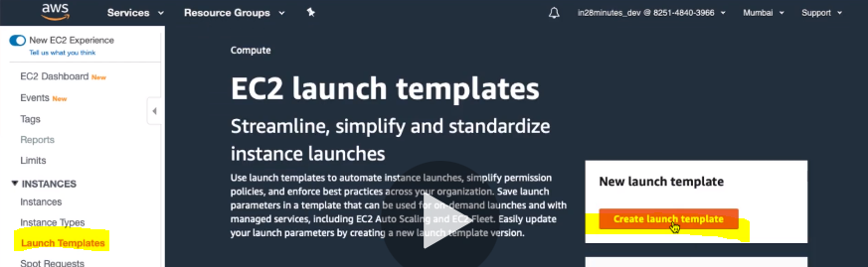

1. Click on Create Launch Tempate:

The another way to create Lauch template from exising EC2 instnaces:

Step:

1. Select the already an exisiting EC2 instance
2. Go to Actions > Click on “ Create Template From Instance”

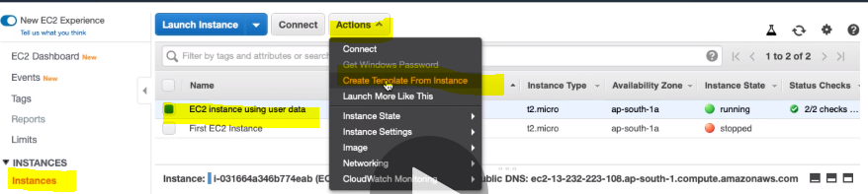

**Put the Launch Template name and its version**

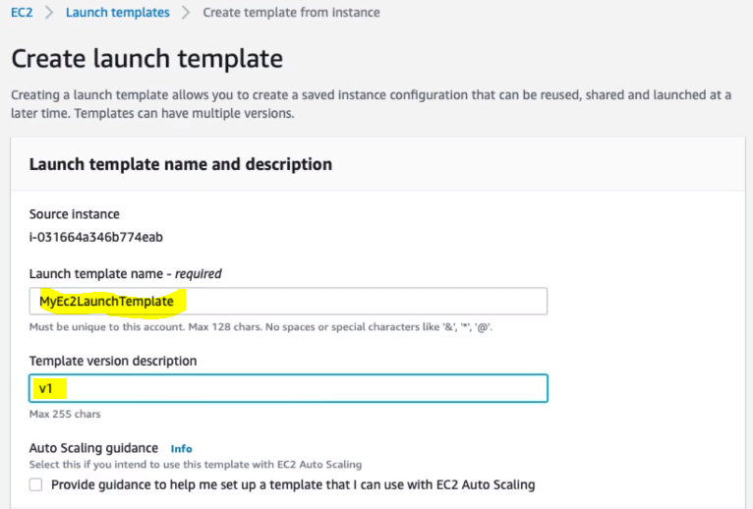

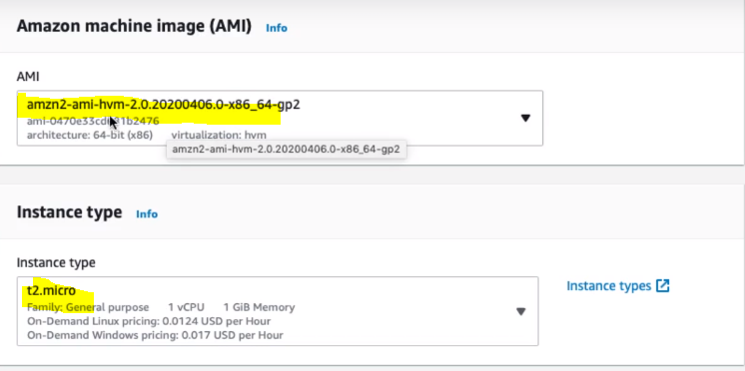

We can see that the AMI and instance type is already selected or chosen. 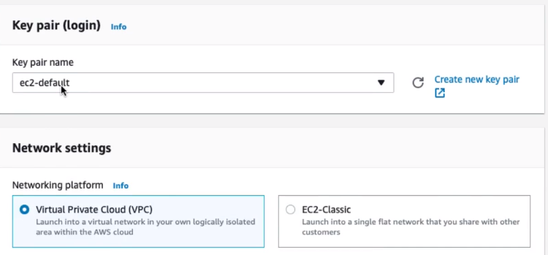 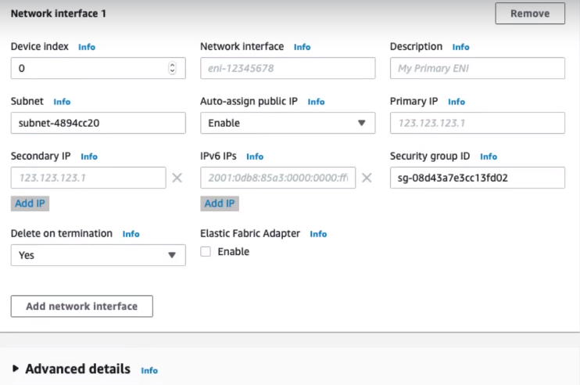

Now if expand Advance detail then we will get info like user data has already been populated

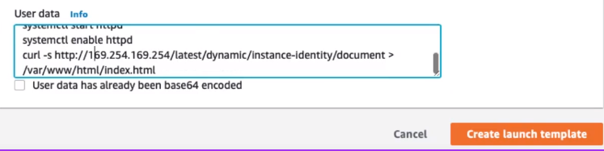

Now click on Create Launch Template: 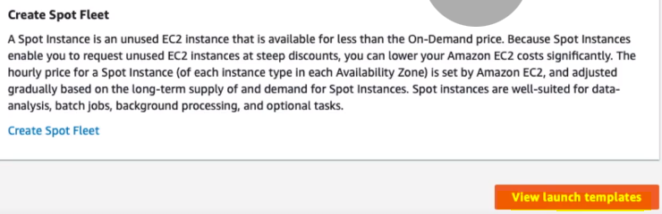

Note: Once we click on Launch Template and check in the EC2 management console then we will not be able to see this newly created EC2 from existing template. So to see newly created EC2 instance->

**Go to Instances > Go to Launch Template > Select the newly created EC2 instance > Go to Action> Launch**

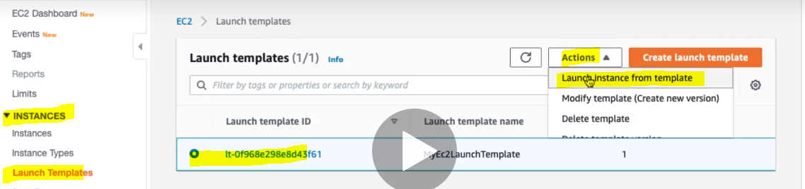 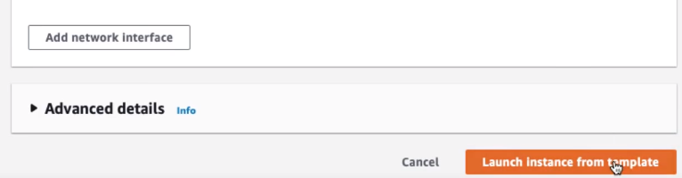

Now finally Launch instance from template

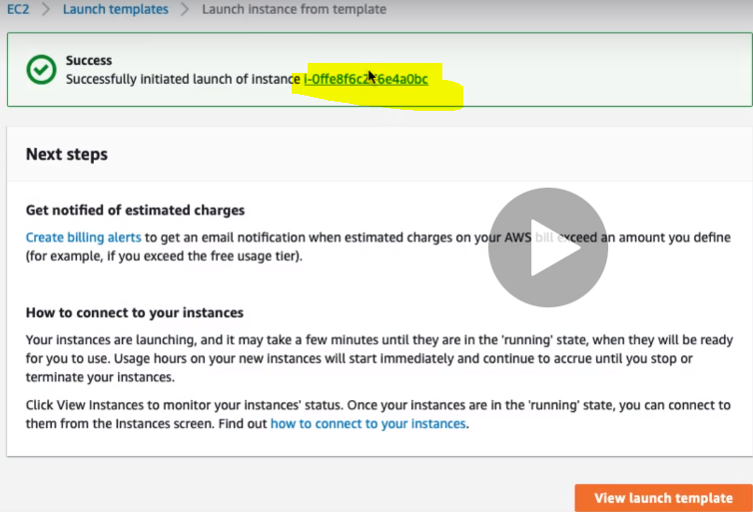

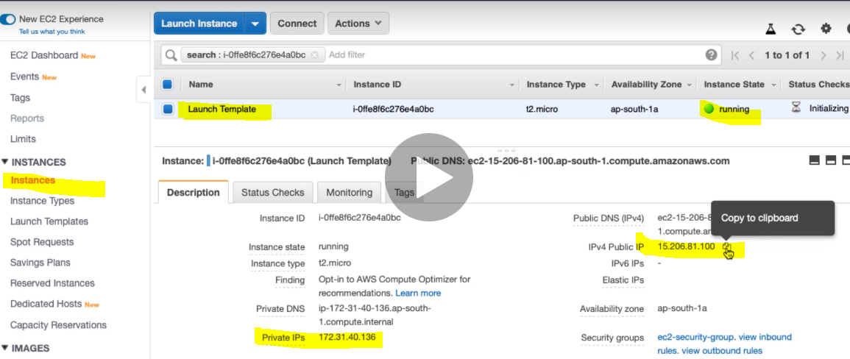

Now to test let’s take its public ip and hit in the broswer and we should get the web page what we have alread configured in the EC2 instace using which we have created this EC2 Lauch Template.

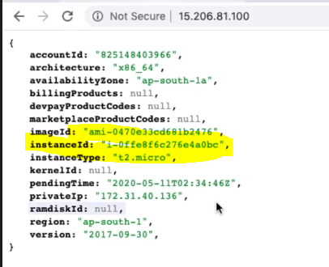

Here we can see the instache id

Hence using launch template we have minimized the the several steps of creating EC2 instance:

So whenever we have to configure something at the EC2 lauch then we can use user-data and when we want to reduce several steps for creating EC2 instance then we can create from existing EC2 instace as template.

**26. Step 12 - Creating Customized AMI for EC2 instance - Part 1**

In this step we will see how we an cutomised AMI for EC2 instace. Unitil now we have used pre-build AMI given by AWS and we were using this AMI for creating our EC2 instances.

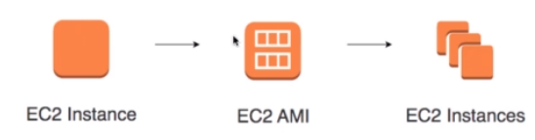

So now we will create our own customized EC2 AMI from an exising EC2 instance and then we will create our own EC2 instances.

**Why should we create pre built AMI?**

Untill now we have been Installing OS patches and software using userdata at launch of EC2 instances which in result increases boot up time. This is usefule for one EC2 intances but when we have lots of EC2 instances to be launched then this is realy not a good approach.

We can solve this problem just by creating our own customized AMIs with OS patches and soware pre-installed this is also called Hardening an Image.

Basically in most of the organization they does not use AWS AMI, instead they take AWS AMI, customized it to create their own AMI.

It is recommended to use customized AMI and use the user data to install OS patches and software.

**DEMO : Create a Customized AMI and using it in Launch Template.**

Steps:

1. Go to EC2 management console
2. Select the already created EC2 instance > Go to Actions > Go to image > Create Image

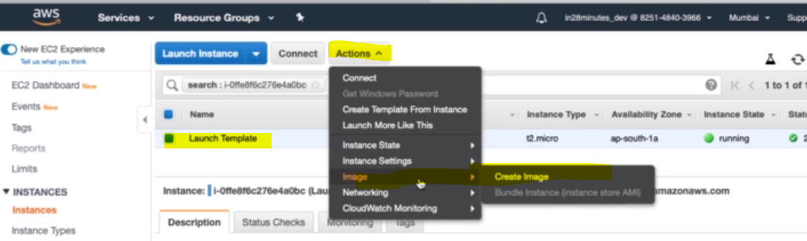

Step-3

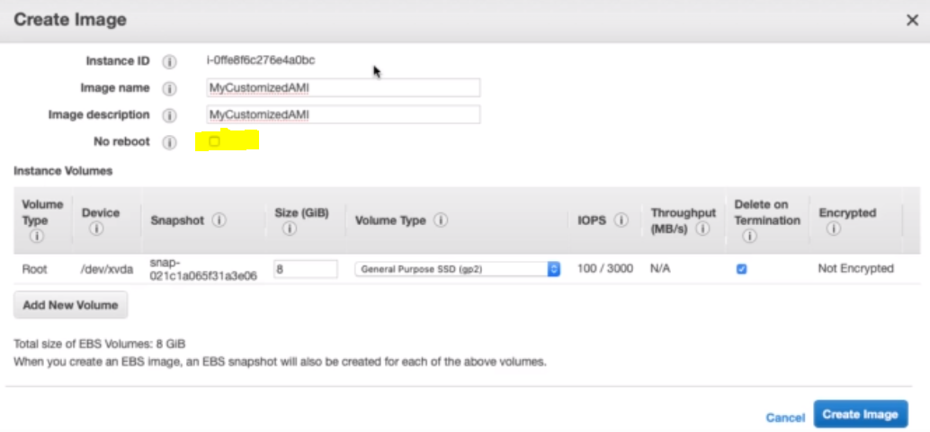

Provde the Name and descripiton:

Note: Here we have one check box for No reboot. Since we are creating AMI from already running EC2 instance so if we check the checkbox then after creating image it will not reboot. But it is recommended to create image after stopping the EC2 instance.

Click on Create Image button.

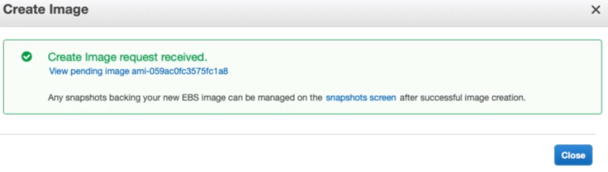

Now the create image request has be received and it will take a while to crete image.

Step-4: Now let’s go to AMI Menu present under Image Section

Now we can see that AMI has been created

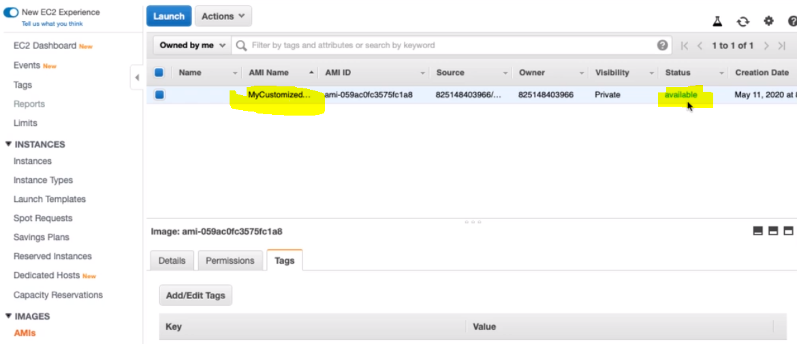

Now using this customized AMI we can create our own EC2 instances from the instances link or we can use the Launch Template .

**Advantage:**

The main advantage of creating our own custom AMI from existing EC2 instance is that we can install the OS patches and general perpose software in our own custome AMI and now when we create EC2 instance from it then we don’t need to install OS patches and general purpose software again the only software which is required for the particular EC2 instance will be installed using user data.

**27. Step 13 - Creating Customized AMI for EC2 instance - Part 2**

Until now we have been created our own customized AMI now let’s create EC2 instance from this AMI using launch template.

Step will be same what we have used earlier : Creation EC2 instace using Launch template, the only difference is that instead of selecting ASW pre-build AMI, we will select our own customized AMI for creating EC2 instance.

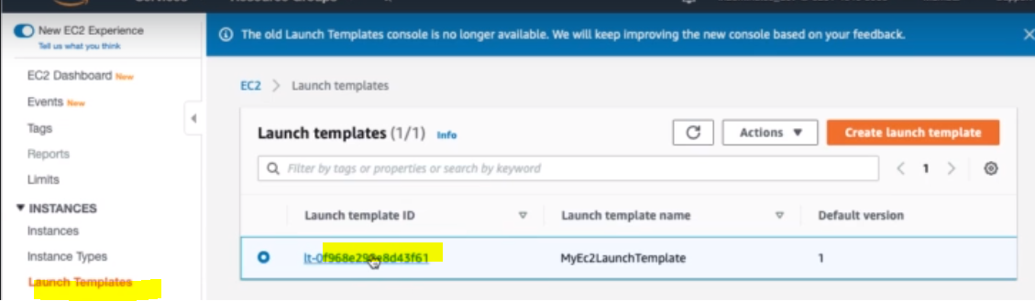

Since we have already one lauch template of version- 1 so let’s create another version of launch template. The good thing is that lauch template can have multiple version. Steps::

1. Click on the Launch Template ID and go to Action to modify template and create a new version.

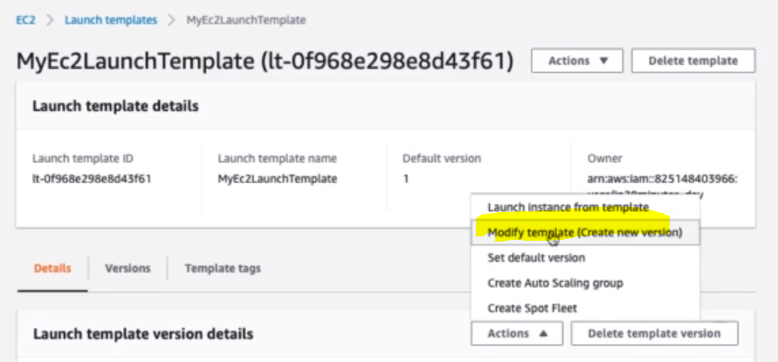

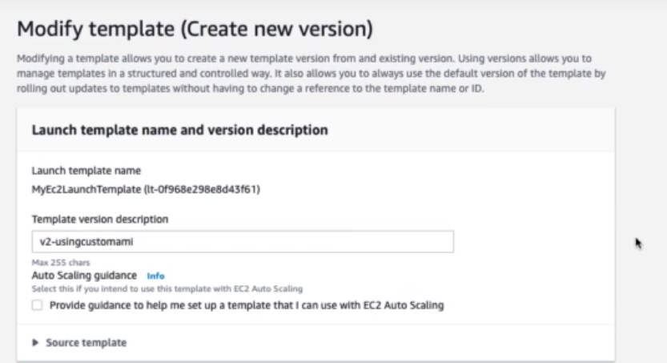Provide the Template Version description: Leave all the setting as default except few things

1. Select our own customized AMI instead of AWS privded AMI

|  |  |
| --- | --- |
|  |  |
| AWS provided AMI | Our own customized AMI |

1. Another one is now we don’t need to install OS package and http server because it is already installed in our customized AMI so we will have specfic userdata related to EC2 instance only

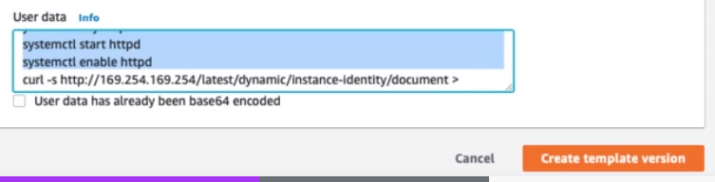Let’s remove and put only related to EC2 as given below.

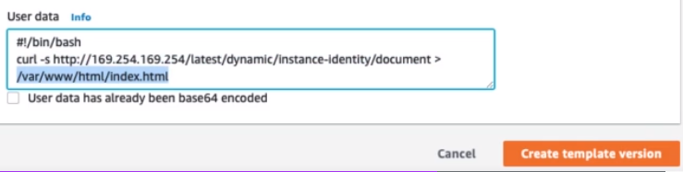

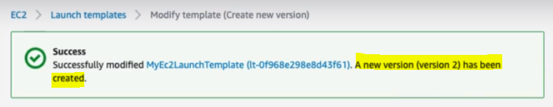

Click on this blue link and lauch EC2 and select our second version of lauch template to create EC2 instance.

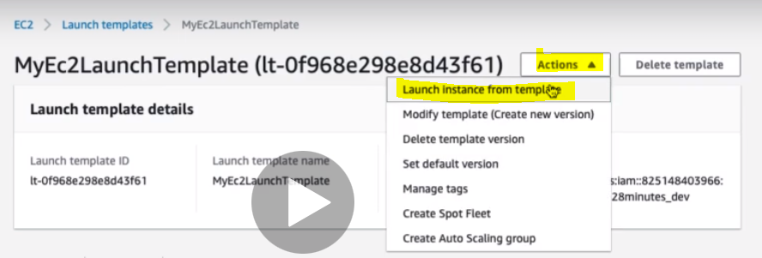

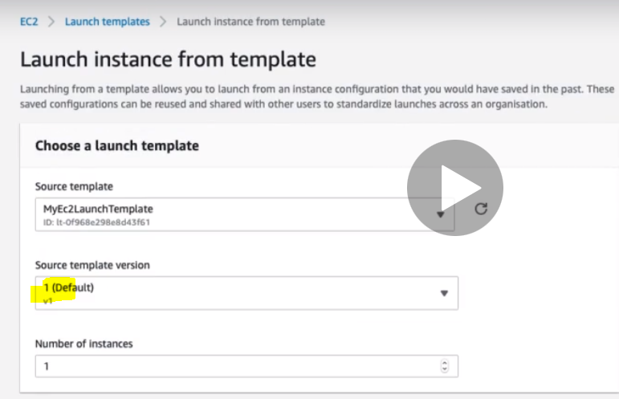

Change from version 1 to version 2 and make this as default.

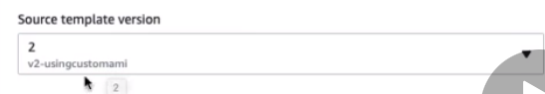

And finally:

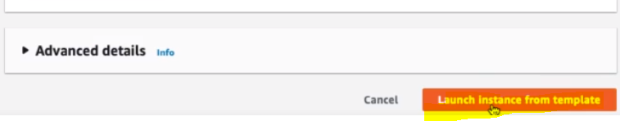

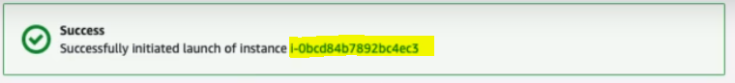

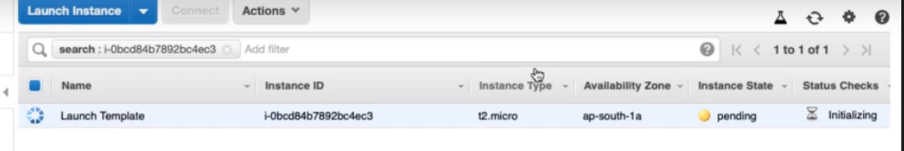

So finally EC2 instance got created from our own customized AMI using Lauch Template.

**Setting default version of Lauch Template:**

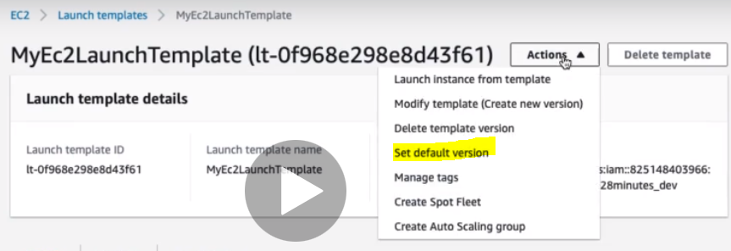

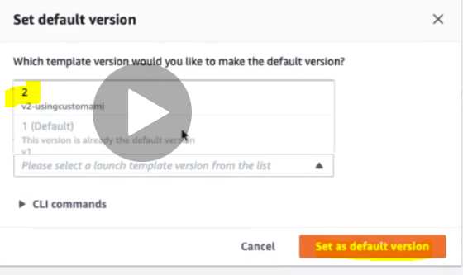

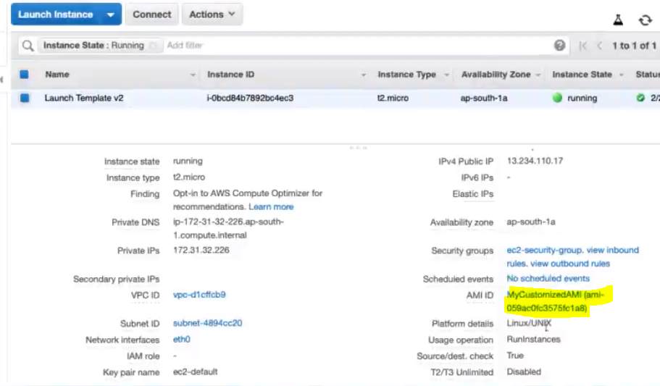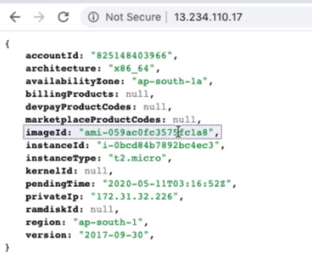

**Querstion comes from here:**

**28. Step 14 - Exploring Amazon Machine Image**

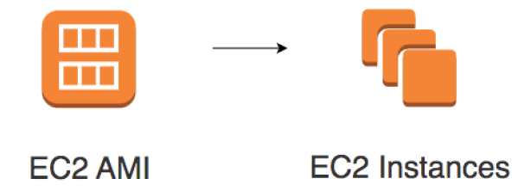

As we know that AMI can be customized to create our own EC2 instance according to need. In AMI we can install operating system and software as a common minimum requirement and can be used in the EC2 instances created with this customized AMI.

Three AMI sources:

* Provided by AWS **AWS Market Place**:
* Online store for customized AMIs. Per hour billing **Customized AMIs**:
* Created by you.

**EC2 Amazon Machine Image - AMI - Remember**

AMIs contains:

* Root volume block storage (OS and applications)
* Block device mappings for non-root volumes

You can configure launch permissions on an AMI

* Who can use the AMI?
* You can **share your AMIs** with other AWS accounts

AMIs is stored in Amazon S3 (**region specific**). **Best Practice**: Backup up to date AMIs in multiple regions

* Critical for Disaster Recovery

**29. Step 15 - EC2 Security - Key Pairs**

Until now we have been using instance connect (CMD) to connet with EC2 instance. Instance connect hides lot of details to connect EC2 instance i.e. it is just a short cut to connect with EC2 instace.

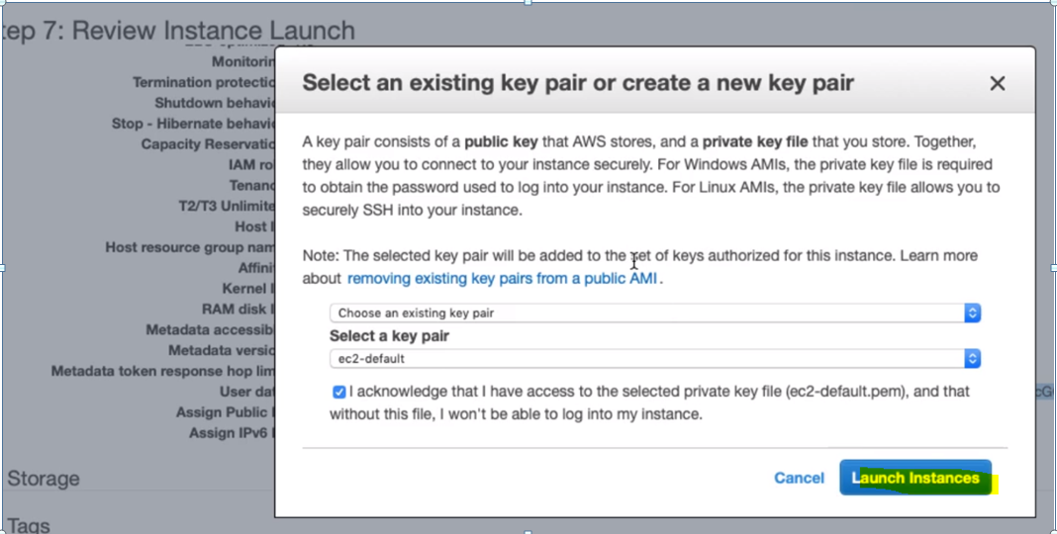

As in the privious discussion during the EC2 instance creation in the last step “Review Instance Lauch” it asked to select an existing key pair or create a new key pair.

As here in the image we can see that A key pair consists of a public key that AWS stores and a private key file that we store. Together they allows us to connect to our instance securily.

For windows AMIs the private key file is required to obtain the password used to log into our instance, while for Linux AMIs, the private key file allows us to securily SSH into our instance.

Earlier when we created EC2 instance then we have used ec2-defult key pair and we used to get one (.pem file) with the same name ec2-default.pem file This is nothing but the private key that we will use during the EC2 instance connect.

If we have already got the key pair then we can use the existing one otherwise we can create a new key pair.

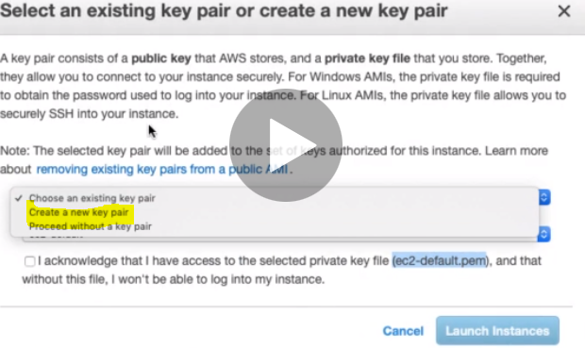

Since we have already created the key pair during first creation of EC2 instance so we will use that key pair only. Let’s see how we can see the key pair for running EC2 instahce.

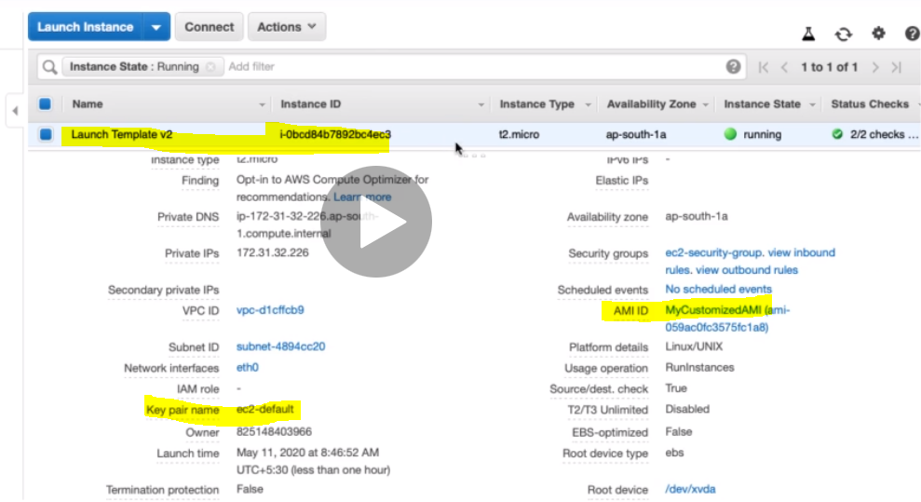

So we can see the key pair which has been used to connect EC2 insatance. This is the EC2 instance which has been created using our own customezed AMI using launch template.

Now if we want to connect This EC2 instance with instance connect (CMD) then click on Connect button and we will get three option.

But only first and last option we will use to connect EC2 instance

1. **EC2 instance connect (browser-based SSH connection) :** This option we have been using so far to connect EC2 instance without using private key. The reason behind is that, the AWS automate the things when we use this option to EC2 instance connect. Here in this case AWS provide private key to EC2 instance, i.e. we don’t need to provide explicitly from our side.

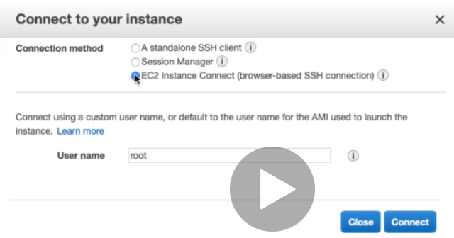

1. **A standalone SSH client :**

Now let’s say I want to connect this EC2 instance from my own local machine or terminal. In that I would have to do SSH from my loacl system to EC2 instance in that case we would have to use first option i.e. A standalone SSH client

The steps are mentioned in the screen shot.

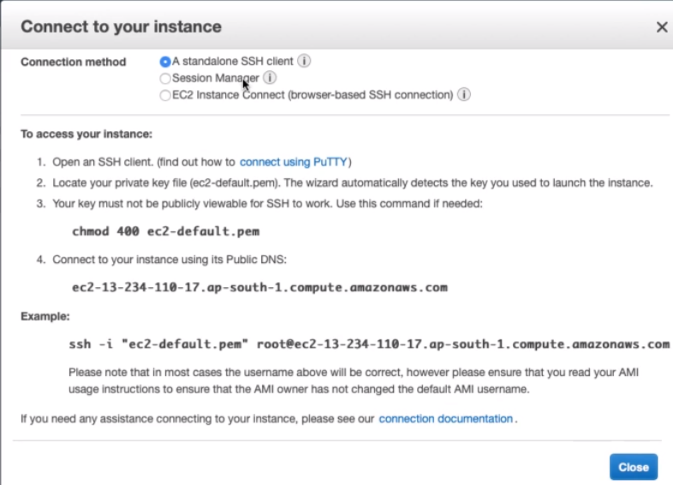

**Connecting from local machine Linux or Mac to EC2 instance.**

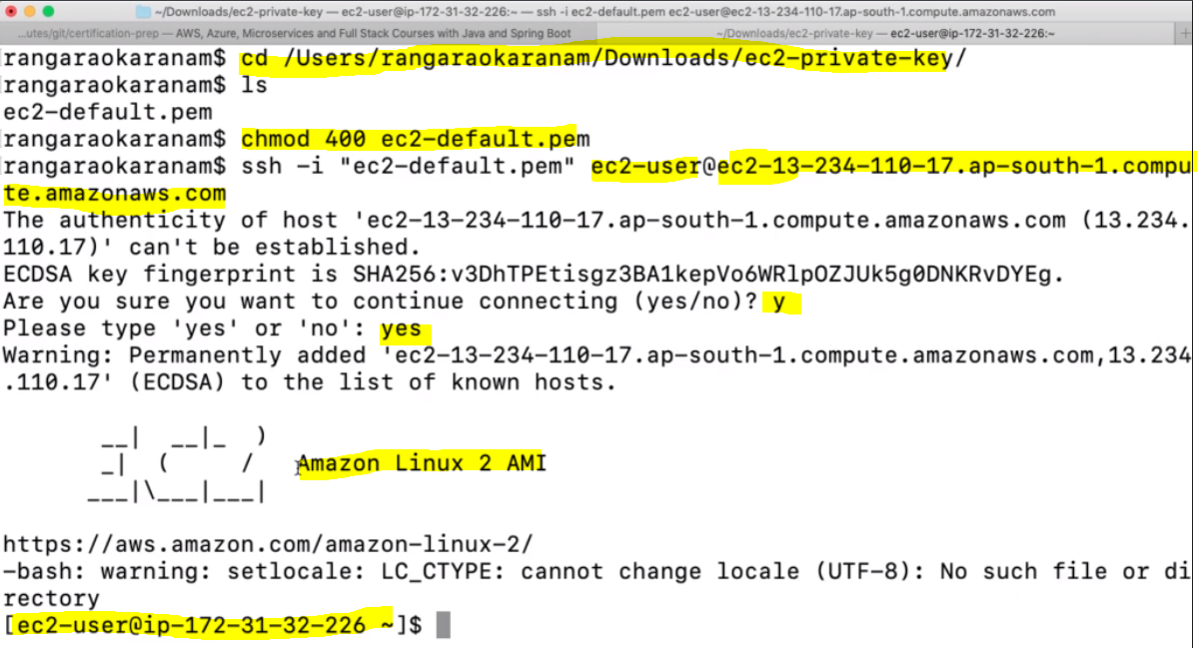

Steps:

1. So first went to the location where the private keypair file is present using cd command
2. Since by default the private key permission might (777) RWM, but to connect we need to change its permission to read only so for that we will run command [ chmod 400 ec2-default.pem]
3. Now do the SSH or connect the EC2 using its public DNS using priavate keypair file and along with username

Note: Here before @ i.e. ec2-user is the root user name and after @ it public DNS

**30. Step 16 - EC2 Security - Connecting from Windows**

If we want to connect our own loacal windows system to AWS EC2 instance then we will have to use ptty

**Connect to your Linux instance from Windows using PuTTY:**

Follow the given link: <https://docs.aws.amazon.com/AWSEC2/latest/UserGuide/putty.html>

**31. Step 17 - Key Pairs Recap & Troubleshooting**

**EC2 Security - Key Pairs**

EC2 uses public key cryptography for protecting login credentials

Key pair - public key and a private key

* Public key is stored in EC2 instance
* Private key is stored by customer

**Connecting to EC2 instance(s) - Troubleshooting**

* **You need to have the private key with you**
* **Change permissions to 0400 (*chmod 400 /path/my-key-pair.pem*)**
* **Default permissions on private key - 0777 (VERY OPEN)**
* **(Windows Instances) In addition to private key, you need admin password**
* **(At Launch) Random admin password is generated and encrypted using public key**
* **Decrypt the password using the private key and use it to login via RDP**
* **Security Group should allow inbound SSH or RDP access:**
* **Port 22 - Linux EC2 instance (SSH)**
* **Port 3389 - RDP (Remote Desktop - Windows)**
* **Connect to your instance using its Public DNS: ec2-**-**-**- **.compute.amazonaws.com**

